e Official Publication of ALDA—An International Association ot security l-roressionais



**Inside:**

**Robert Scheuetrumpf, CRL**

**Conquers a Complex Institutional Job**

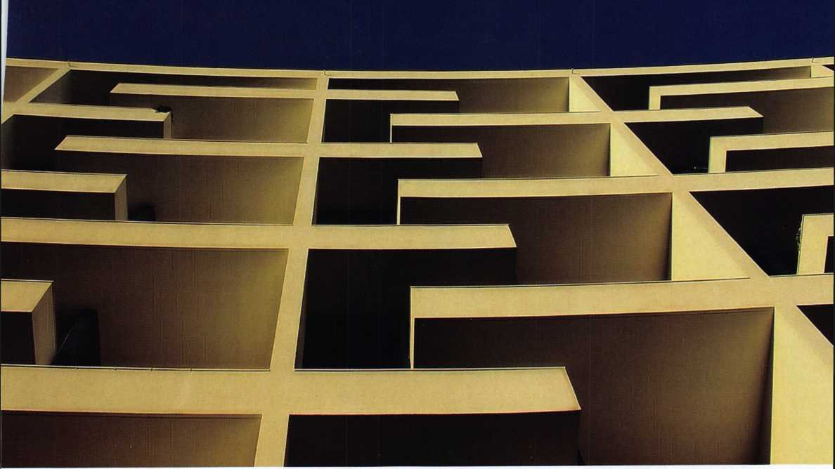

PLUS!

Greg Perry reuiews  
Safetech 2005 and TruCenter,  
The Harry Miller Story,

Eric Costley Reuisits Spherical  
Keying, T.F. Stern offers a  
technologically-colored uieiu of  
locksmithing’s future, and MORE!

***************££^ 3-DIGIT 303 Breck H. Camp CML PO Box 47070 Atlanta GA 30362-0070

liiliilliiiiilliilliMililllmlimliiillliiiliiillliiiiilill



OUR STAND



IT'S YOUR TRANSPORTATION, OFFICE,

AND LUNCHROOM.

YOUR INSURANCE COMPANY SHOULD BE

You’re in good hands.

**locksmiths**

Subject to availability and qualifications. Allstate Insurance Company and Allstate Indemnity Company, Northbrook, IL. Allstate County Mutual Insurance Company, Irving, TX. Allstate New Jersey Insurance Company Bridgewater, NJ.Tlie “Cupped Hands" ijwjo is a registered service mark and “Our Stand" is a service mark of Allstate Insurance Company. © 2005 Allstate Insurance Company, Northbrook, (L.

**JUST AS VERSATILE.**

Get commercial vehicle protection from Allstate.

We know just how important your vehicle is to your products for your small business, including commercial business and the many roles it plays. That's why your auto insurance. All designed to help keep your busi-

local Allstate agent offers a wide range of insurance ness rolling along. Are you in Good Hands®?

1-800-859-0247

**CALL NOW TO LOCATE YOUR NEARBY ALLSTATE AGENT.**

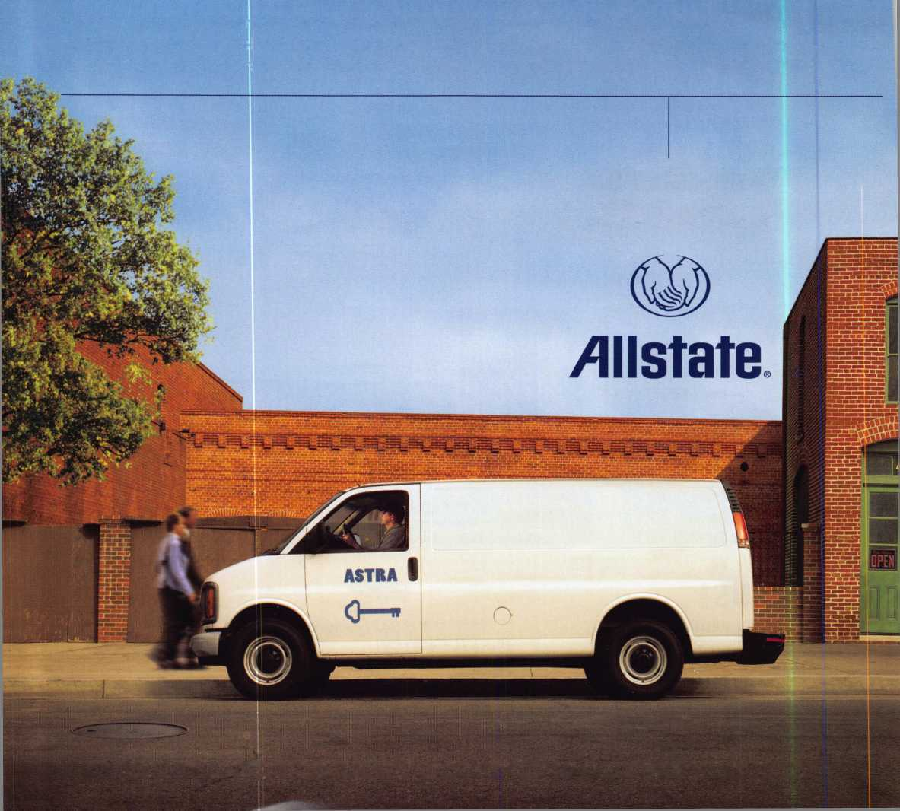

Use ALOA'S Fax

Just call 310-575-

1. ALOA Inde:
2. Becoming i
3. Locksmith <

**Get What's  
Coming To You**

ALOA continues to provide you with this and other great benefits and services!

in a hurry?

Demand service.

r4 and receive:

of Documents  
Locksmith <ipg)

Summary (3pg)

Locksmith School List (2pg)

ACE Class

r lnformation(3pg)

PRP Category List (Ipg)

ALOA Membership App!ication(2pg) ALOA List of Benefits (Ipg) Scholarship Application Form (Ipg) ALOA Video Library Order Form (Ipg) ALOA Membership Items Order Form (Ipg)

Safe & Vault Technicians Association Member Application/Subscription Form (2pg)

ALOA Chapter Roster (3pg)

Legislative Action Network (2pg) Legislative Action Network Newsletters (Ipg)

Various State Laws (lOpg)

Industry Position Pager (Ipg)

Current Legislative Action Network Newsletters (Ipg)

Board of Directors Nomination Form (2pg)

ALOA Convention Registration ALOA Board Expense Reimbursement & Request Form

Call Today!

310**-**575-5074



BETTER

THAN

EVER.

Available 7/22/05  
At ALOA  
Rosemont, IL

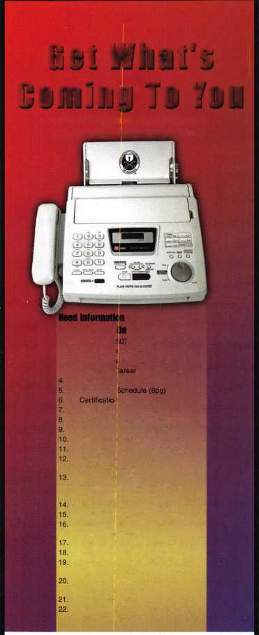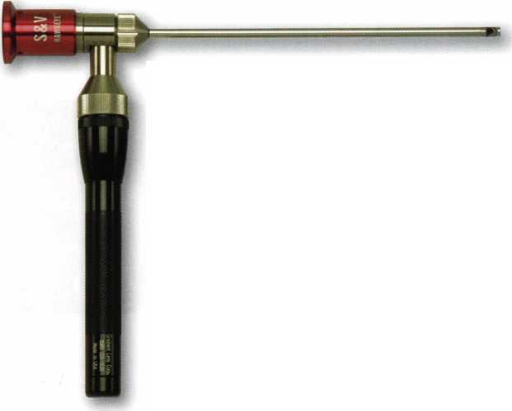

|  |  |  |  |  |
| --- | --- | --- | --- | --- |
| p r 1 | e s i d | e n 1 | rial |  |
| v | i e w | p o i | n t |  |

Important

Notice

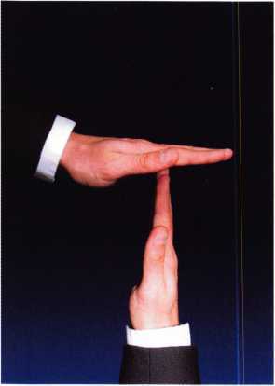

The Headquarters of the Associated Locksmiths of America will be relo­cating to a new office building about the 1 st of May. During the time of the move, some ALOA services will be temporarily unavailable. These services include, but ar not limited to, the following:

* Incoming Calls
* Database Inquiries
* Staff Support for the Web and all other departments

It is suggested that all ALOA and SAVTA members make note of this change. (This ad will be ammended when the actual move dates are confirmed.)

The ALOA staff is looking forward to the new location and the opportunity to provide you with improved mem­ber services during 2005. Watch the latest news section at [www.aloa.org](http://www.aloa.org) for more information.

**2**

Dear Members,

I have just returned from what has to be one of the best  
SAFETECH conventions in history as evidenced by the turnout  
(including an invasion of 29 Swedes) and class participation.  
Lexington, Kentucky is the safe lock capital of the world and  
Lockmasters, Sargent and Greenleaf, Kaba-Mas, Timemas-  
ters, and MBA were all gracious hosts. I would like to con-  
gratulate Lockmasters on their 50th Anniversary and person-  
ally thank the Miller family for their generosity and hospitality  
at this event. I would also like to congratulate LaGard on it's

30th Anniversary and thank them for their sponsorship and support. The ALOA/SAVTA staff  
deserves a round of applause, as does Mike Oehlert, whose hard work makes this convention  
a success.

The turnout at the SAVTA membership meeting was equally impressive. Ron Snively and his board  
are working hard to meet the needs of all safetechs and continue to work well with ALOA. I am  
also pleased to recognize the achievements of two personal friends, Dave Wells and Skip Eck-  
ert, who were both elected to the SAVTA Hall of Fame. Dave and Skip have served SAVTA tire-  
lessly... they were the first two SafeTechs appointed to the SAVTA board following SAVTA's  
purchase by ALOA. It is a well-deserved honor for both.

I was very pleased to hear at the SAVTA membership meeting that the SAVTA board is also con-  
sidering increasing the standards to become a SAVTA member. This follows suit with what ALOA  
is doing and is intended to promote professionalism and increase the image of security pro-  
fessionals by ensuring that we are QUALIFIED to meet the security standards that are necessary  
in our current environment!!!!

As president of ALOA it is my DUTY to remind all of our members that it is their DUTY to vote  
in the upcoming election. The ballots will be coming out in the May issue of Keynotes. There  
are three qualified and competent candidates running for president, there are three directorships  
up for election, and there are multiple bylaws changes that warrant your interest and accept-  
ance. This is your voice in the association! Don't let it go to waste. This year, casting your proxy  
is easier than ever with new secure online voting. The objective... we want ALL of you to vote!

Sincerely,

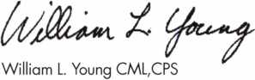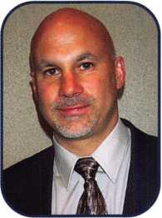

Keynotes • April 2005

If •% «/>

rjt*

**The HLOR**

**Conuention**

**and Security Expo July 17-24, 2005**

SLUEET

Get Ready for RLOR 2005,

a powerful resource to explore innouation and form industry alliances. This year we’ue thought of euerything from an exciting location, comfort­able accommodations and a conuention center that is equipped to handle your euery need.

Located just minutes from downtown  
Chicago, Rosemont, Illinois is the  
perfect “business uillage”, designed specifically  
to make your stay conuenient, comfortable  
and aboue all, successful!

The 49th Annual RLOR Conuention and Security Expo  
offers top-notch classes, workshops, networking  
opportunities and cutting-edge technology.

Rnd don’t miss out on the fine dining and enter-  
tainment options that Chicago has to offer. Shop  
at the world-famous Magnificent Mile. Eat at  
Morton’s of Chicago or Harry Caray’s Italian  
Restaurant. Uisit the Nauy Pier or catch a ball  
game. The options are endless when you register  
today for the single-most important euent in  
the locksmithing industry.

Baby, you know you want to yo!

**RLOR 2005**

Sweet Home Chicago

fcrTfte- II

■ ' .

I

|

1

in

features

INSTITUTIONAL LOCKSMITHING 2005

**10**

A Townhouse Complex Complex Problem

After starting as a locksmith last year at the College of New Jersey, I spent the first few months learning the layout of the campus and getting acquainted with the locking sys­tems. In late May, 2003, our electronic technician was called to active military duty in Iraq and I was suddenly thrown into the position of maintaining the electronic access systems on campus.

By Robert Schuetrumpf, CRL

**14**

SAFETECH 2005 Wrap Up

WOW-what a great convention! If you were not in Kentucky for the 2005 Safe and Vault Technicians Association convention, you missed a great opportunity.

by Greg Perry, CML, CPS

**20**

What is a Locksmith?

This is where I begin to see the future, a future where lock­smiths may become obsolete. I have watched the electron­ic industry take hold of much of what used to be consid­ered the locksmith industry.

by T.F. Stem

**22**

TruCenter Book Review

"TruCenter The Harry C Miller Story" by A. M. Davis is more than just an ordinary biography. It details not only Harry's life but also a history of safe lock collecting, Harry's favorite pastime.

by Greg Perry, CML, CPS

**24**

The Magic of Spherical Keying Revisited

Just when we all thought that the uses of spherical Master keying had been exhausted, a few new quirks emerged from some e-mails and conversations that have proven that the use of the sphere is even more flexible than we origi­nally thought.

by Eric Costley, CRL

**Departments**



Another Trade Show - Be Smart!

You've been asked to attend another trade show. Envious co-workers wish they could also "escape" from a day at the shop and attend. But is this really a day off?

by Claire L Cohen, CML

|  |  |
| --- | --- |
| r |  |
| AD INDEX |  |
| Allstate Inside Front Cover | |
| Gradient Lens | 1 |
| Sodium Halogen | 7 |
| Keedex | 11 |
| Professional Business Products | 13 |
| ALOA Vote | 17 |
| SAFETECH 06 | 29 |
| Hinge Doctor | 35 |
| Defiant Safe Company | 41 |
| Findalocksmith.com | 43 |
| Master Lock Inside Back Cover | |
| CCL Back Cover | |
| L | 1 |

Presidential Executi

ViewP°inf 2 App

ive 5 Calendar 8 Classified 36 Legislative 40

I cants 6 Core 9 Associate

Members 38

Visit our NEW website at [www.aloa.org](http://www.aloa.org)

executive

Volume 51, Issue 4

Additional contact information for the ALOA Board and most Keynotes authors is  
available through "Locksmith Search7" on the ALOA Web site- [www.aloa.org](http://www.aloa.org) or by  
contacting the ALOA office at 3003 Live Oak Street; Dallas, TX 75204; (800)532-2562;  
FAX (214)827-1810; e-mail [aloa@aloa.org](mailto:aloa@aloa.org).

|  |  |
| --- | --- |
| Editor  Betty Henderson | [betty@aloa.org](mailto:betty@aloa.org) |
| Technical Editor  David Lowell, CML, CMST | [david@aloa.org](mailto:david@aloa.org) |
| Editorial Advisor  John Cannon, CML | jcannonl @cox.net |
| Advertising Sales  Kim Hammond | voice: 817-645-6778 |
| Executive Director  Charles W. Gibson, Jr., CAE. | Fax: 817-645-7599 e-mail: [adsales@aloa.org](mailto:adsales@aloa.org)  [charlie@aloa.org](mailto:charlie@aloa.org) |

Associate Executive Director

David Lowell, CML, CMST [david@aloa.org](mailto:david@aloa.org)

Convention & Meetings Manager

Jo Anne Mims [joanne@aloa.org](mailto:joanne@aloa.org)

Operations/Membership Manager

Mary May [mary@aloa.org](mailto:mary@aloa.org)

Government Relations Manager

Paul Kanitra [paul@aloa.org](mailto:paul@aloa.org)

Director of Communications

Betty Henderson [betty@aloa.org](mailto:betty@aloa.org)

IT Operations Manager

Greg Jackson [greg@aloa.org](mailto:greg@aloa.org)

Comptroller Kathy J. Romo

Membership Coordinator Shelly Jett

Convention & Meetings Assistant Karen Lyons  
PRP/Education Coordinator Hope Rodriguez

Mail Room Coordinator Kevin Wesley

Publications Coordinator Bryan Dease

Administrative Assistant Jen Gilson-Gilliam

Executive Assistant Sue Langford

Contributors

Jerome Andrews, CML  
Paul Chandler, CRL  
Claire Cohen, CML  
Brian Costley, CML, CMST  
Eric Costley, CRL

Ray D'Adamo, CML Billy Edwards, CML Dan Graffeo, CRL,CMST Jim Hancock, CPL Jeff Nunberg, CML, CMST

Randy Simpson, CML, CPP Robert Stafford, CML Dave Thielen, CML Greg Perry, CML,CPS

Tom Seroogy

Charles Stephenson, CPS

Dennis Watanabe, CML, CMST

Mission Statement: The Associated Locksmiths of America, Inc. is dedicated to enhancing the professionalism, education and ethics among locksmiths and those in related sectors of the physical security industry. With approximately 10,000 members in the United States, Canada and the freeworld, ALOA is poised to help members obtain the knowledge, the strength, and the confidence to perform their role in the physical security field with pride and dignity. But it is only through active involvement and participation that ALOA can fully achieve its potential—and can help members to achieve theirs.

Policies: Keynotes® is the official publication of the Associated Locksmiths of America, Inc. (ALOA). Keynotes® acts as a moderator without approving, disapproving, or guaranteeing the validity or accuracy of any data, claim, or opinion appearing under a byline or obtained or quoted from an acknowl­edged source. The opinions expressed by the authors do not necessarily reflect the official views of ALOA. Also, appearance of advertisements and new products or service information does not constitute an endorsement of products or services featured by the Association. The Association does not accept responsibility for the inaccuracy of any data, claim, or opinion appearing in this publication, due to typographical errors on the part of the authors, Association staff or its agents.

Editor's Note: This publication is designed to provide accurate and authoritative information in regard to the subject matter covered. It is provided and disseminated with the understanding that the publisher is not engaged in rendering legal or other professional services. If legal advice and other expert assistance is required, the services of a competent professional should be sought.

Authors' Payment: Payment for eligible submissions to Keynotes will be based on the following criteria: topic, time spent and past contributions. Authors who regularly submit to Keynotes® are generally paid a higher rate. The latter is especially true of authors who write to fit specific editorial needs and submit said copy by Keynotes® deadlines. As a general guideline: Average payment for a 750 word, business or 'light' technical article would be $200. Payment for a 1500 word article involving significantly higher time and research efforts would be $400.

Payment will not be offered for articles submitted by ALOA employees or members of the ALOA Board of Directors (unless material is of a technical nature), nor for articles submitted by a company that promote that company's products or services. ALOA reserves the right not to pay for articles sub­mitted by an individual(s) that promote a particular company's products or services.

Disclaimer: The Associated Locksmiths of America, Inc., (ALOA), reserves the right to refuse any article for any reason. Additionally, ALOA reserves the right to edit, amend or modify any article submitted for publication in order to preserve technical accuracy, clarity, fairness or grammatical cor­rectness. ALOA will make the best efforts to notify the author of any changes. The extent of ALOA's liability for any article or information contained therein will be a notice of correction or retraction in the next possible issue.

Keynotes® (ISSN 0277 0792) is published monthly except for the combined June/July issue by The Associated Locksmiths of America, Inc., 3003 Live Oak St., Dallas, TX 75204-6186. Telephone: (214) 827-1701; FAX (214) 827-1810; e-mail [aloa@aloa.org](mailto:aloa@aloa.org). Subscription rates for members—$15.00 per year. Periodical class postage paid at Dallas, Texas. POSTMASTER: Send address changes to: Keynotes, 3003 Live Oak St., Dallas, TX 75204-61 86. © Copyright 2003, All rights reserved. No part of the contents may be reproduced or reprinted in any form without prior written permission of the publisher.



President

William L. Young, CML  
(610)647-5042  
[president@aioa.org](mailto:president@aioa.org)

Secretary

John Soderland, CML, CMST  
(414) 327-5625  
[secretary@aloa.org](mailto:secretary@aloa.org)

Directors, Northeast

Robert E. Mock  
(856) 863-0710  
[nedirector@aloa.org](mailto:nedirector@aloa.org)

Peter Sarailian, CRL  
(973)890-9797  
[nedirector@aloa.org](mailto:nedirector@aloa.org)

Vernon Kelley, CPL  
(609)771-3126  
[nedirector@aloa.org](mailto:nedirector@aloa.org)

Directors, Southeast

Tom Gillingham, Jr., CML, CPS  
(615)264-0747  
[sedirector@aloa.org](mailto:sedirector@aloa.org)

Ken Kupferman, CPL  
(813)961-5784  
[sedirector@aloa.org](mailto:sedirector@aloa.org)

Director, North Central

Mark E. Blum, CML, CPS  
(517) 482-5809  
ncdi rector@aloa. org

Director, South Central

CD Lipscomb, CML, CPS  
(903)874-3522  
[scdirector@aloa.org](mailto:scdirector@aloa.org)

Directors, Southwest

Gordon R. Racine, CML  
(719) 384-4707  
[swdirector@aloa.org](mailto:swdirector@aloa.org)

Julie McCluney, CRL  
(714) 636-5652  
[swdirector@aloa.org](mailto:swdirector@aloa.org)

Director, Northwest

Jim Jeffries, CPS  
(208)743-1101  
nwdirector@aloa .org

Director, European

Hans Mejlshede, CML  
(453)539-3939  
[eurdirector@aloa.org](mailto:eurdirector@aloa.org)

Director, Asian

joe J. Lee, CRL  
(215)289-2404  
[asiandirector@aloa.org](mailto:asiandirector@aloa.org)

Director, Associate

Paul M. Justen  
(800)333-6953  
asd i rector@aloa. org

Trustees

[trustees@aloa.org](mailto:trustees@aloa.org)

Randy Simpson, CML  
(281)2405959

John J. Greenan, CML, CPS  
(773) 486.2030

Past Presidents

2001-2003 Randy Simpson, CML  
1999-2001 John Greenan, CML, CPS  
1997-1999 Dallas C. Brooks  
1995-1997 David Lowell, CML, CMST  
1993-1995 Breck Camp, CML  
1991-1993 Henry Printz, CML  
1989-1991 Evelyn Wersonick, CML, CPS  
1987-1989 Leonard Passarello, CPL  
1985-1987 Joe Jackman, CML  
1983-1985 Stanley Haney, CPL  
1981-1983 Louis LaGreco, CPL  
1979-1981 John Kerr, RL  
1977-1979 Clifford Cox, CML  
1974-1977 Charles Hetherington  
1972-1974 Gene Laughridge  
19701972 William Dutcher, RL  
1968-1970 Constant Maffey, RL  
1966-1968 Harold Edelstein, RL  
1964-1966 William Meacham  
1962-1964 Robert Rackliffe, CPL  
19601962 Edwin Toepfer, RL  
1956-1960 Ernest Johannesen

Keynotes • April, 2005

AZ

GA

applicants

for membership



t

i

Tempe

Robert Brenghause

Sponsor: William Lee CRL

CA

Antioch

Joseph L Grant

Spons or: J D. DeSousa

Los Gatos

Samuel S* Hahn

Sponsor: Willy K. Yee

Pinedale

Rachel A. Alvarez

Sponsor: Noa Kristi

Richmond

Ramon Tan-Torres

Santa Barbara

Seymour W. Duncan

Sponsor: William P. Grant CRL

co

Fort Collins

David McCandless III

Sponsor: Raymond J. D'Adamo CML

Nunn

Mary Moffett

FL

Jacksonville

Geoffrey A. Knowell

Savannah

Marvin W. Mock

Sponsor: Michael Schuman

Niles

Kenneth O. Menard

Sponsor: Gerald O. Menard CRL

IN

Indianapolis

Robert W. Robinson

Sponsor: Jim Williams CRL

South Bend

Edward L Gay

Sponsor: Jack W. Seifer

Lexington

Julia Hood

LA

Lake Charles

Jeff Mallett

MD

New Carrolton

Noris Leonzo-Ortiz

Sponsor: Michael C. Olson CRL

Temple Hills

Marquette Pierce Jr

Sponsor: Michael C. Olson CRL

ME

Bar Harbor

Michael A. Curry

Sponsor: Tom W. Olson

MN

Minneapolis

Rebecca Hrobak

Sponsor: Dana L Lee CML

Willmar

Gary W. Pearson

Sponsor: Myron H. Krupa

NC

Statesville

Richard R. Shuford

Sponsor: Charles E. Batcke CRL, CPS

John Campbell

Sponsor: Charles E. Batcke CRL, CPS

NM

Albuquerque

Colleen M. Fadgen

Sponsor: William A. Fadgen Jr, CRL

NV

Las Vegas

Steven J. Belt

Sponsor: Ernest W. Wright

OH

Montpelier

Joshua Nicolen

These applicants are scheduled for clearance as members of ALOA. The names are published for member review and comment within 30 days of this Keynotes issue date,  
respectively, to ensure applicants meet standards of ALOA's Code of Ethics. Protests, if any, should be addressed to the Membership Department and must be signed. Active  
Membership applicants (a) have worked in the industry two or more years. Allied Membership (AL) applicants are not locksmiths, but work in a security-related field.

Apprentice Membership (AP) applicants have worked in the industry less than two years.

Keynotes • April 2005

Warren

TX

WA

John R. Morris

Sponsor: George C. Blair

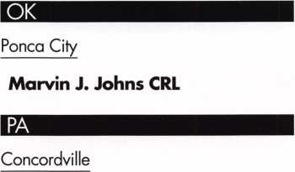

Michelle Glynn

Philadelphia

George L. Griffin

Dallas

Eric Anapol

Sponsor: Dawn M Forgey CRL

VA

Arlington

Ferdinand I. Medina

Sponsor: Michael B. Groves

David Ebb

Sponsor: Michael B. Groves

Issaquah

Kevin Klemmer

Sponsor: Cory Klemmer

Australia

Woolloongabba AL

Aaron Boyd

Canada

ON - Hamilton

Ronald J J. Dastous

Sponsor: Peter K. Gauthier CPL, CPS

fou are spending **WHAT** on Yellow Pages advertising?!

Unlock your company’s potential with a new Web Site.

* The Facts? One in three Americans use an internet search engine, (according to Nieisen//NetRatings)

Most locksmiths have no presence on the internet at all.

* Translation? One third of the people looking for your business won’t be able to find you.
* Solution? Sodium Halogen interactive design.

Let the same company that designed AL0A.org give you online results - for less than you may be paying for yellow page advertising. Site makeover, search engine placement or starting from square one - visit **[www.YouAreSpendingWhat.com](http://www.YouAreSpendingWhat.com)** to see why Sodium Halogen is your solution.

Mention this Ad for a 10% ALOA member discount!

[saies@sodiumhalogen.com](mailto:saies@sodiumhalogen.com)

972-839-8913

Keynotes • April 2005



p c o m i n g

events

u

7-9 California Locksmiths Associc Trade Show & Educational Program

21 KDL Trade Show

For more info contact:

Julie Pilgrim-206-682-7383

|  |  |  |
| --- | --- | --- |
| 8-11 International Assocation of  Investigative Locksmiths Annual Conference Baltimore, Maryland Contacts: Don Shiles 410-674-77 Lenny Podgorski 410-516-8269 | 15 IDN Trade Show and Security Expo  Ypsilanti, Michigan For more information Contact Ronald Weston,  21 Marketing Manager 734-591 -4828  or Bonnie Weston 734-591 -4821 | |
|  |  | sMIi |

UPCOMING ACE CLASSES

UPCOMING PRP SITTINGS

|  |  |  |
| --- | --- | --- |
| 4/23-24/2005 | White River Junction, VT • Green Mountain Locksmiths Association | 4/07/2005 |
|  | Bradley Manchester 802-863-4153  Comprehensive Access Control (2 days) | 4/09/2005 |
| 4/28-30/2005 | Denver, CO • Central & Southern Colorado Locksmiths Assn  Gordon Racine, CML 719-384-4707 • 9 Ace Classes | 4/10/2005 |
| 5/14/2005 | Detroit, Michigan • Locksmiths Security Association  Robert C. Nobel, CPL 810-385-9329  Electronic Safe Locks | 4/30/2005 |
| 7/17-24/2005 | Rosemont(Chicago), Illinois • ALOA 49th Annual Convention & Security Expo • David Lowell, CML,CMST 800-532-2562 xl8  70 full day classes • 35 half day classes & evening seminars | 5/12/2005 |

Thursday 9:00am Dallas, TX ALOA  
Hope Rodriguez 800-532-2562

Saturday 8:00am • Ontario, CA • California Locksmiths Assn  
Suzanne Harmony 714-632-6800

Sunday 8:30am • Bozeman, MT • Montana Chapter of ALOA  
• Winston Morissey 406-586-51 87

Saturday 6:00pm • Denver, CO • Central & Southern Colorado  
Locksmiths Assn • Gordon Racine, CML 719-384-4707

Thursday 9:00am • Dallas, TX • ALOA  
Hope Rodriguez 800-532-2562

8/22-27/2005 Dallas, Texas • ALOA ACE Program

Hope Rodriguez 800-532-2562 x30  
6 day basic locksmithing course

10/11-15/2005 Portland, Oregon • Pacific Locksmths Association  
Bill Botek, CRL 503-644-9881  
Life Safety Codes w/L07 PRP  
Fundamental Locksmithing (2 days)

Servicing Aluminum Storefront Doors  
Safe Combination Lock Servicing  
Basic Electricity w/L13 PRP  
Advanced Shop Management  
Professional Impressioning Techniques

5/21/2005 Saturday 5:30pm • Seattle, WA • KDL Harware Supply, Inc

Julie Pilgrim 206-682-7383

7/22/2005 Friday 6:00pm • Rosemont, IL ALOA 2005 • Hope Rodriguez

800-532-2562x30

10/09/2005 Sunday 9:00am • Orlando, FL • SERLAC 2005 • James Barnhardt, RL

813-689-5979



Cell Phone Locksmith?

The following email has recently circulated through the ALOA Headquarters. Read on to see how David Lowell debunks this urban legend.

Ever locked the keys in the car?

If you lock your keys in the car and the spare keys are home just call someone on your cell phone who has another set.

Hold your cell phone about a foot

from your car door and have the  
other person at your home or  
wherever press the unlock button,  
holding it near the phone on their

end.

Your car will unlock. Saves some-

one from having to drive your keys

to you.

Distance is no object. You could be hun-

dreds of miles away and if you can reach  
someone who has the other "remote" for your  
car you can unlock the doors (or the trunk!).

Editor's Note: It works fine! We tried and it unlocked our car over a cell phone!

Comforting though it may be to imagine you can unlock your car door in an emergency by receiving a distant signal via your cell phone, it can't possibly work—not with the technology as it now stands, Here's why:

Your remote car key operates by sending a weak, encrypted radio signal to a receiver inside the auto­mobile, which in turn activates the door locks.

Since the system works on radio waves, not sound, the only conceivable way a signal from your spare remote could be picked up by one cell phone and

relayed to your car's onboard receiver by another would be if both phones were capable of sending and receiving at exactly the same frequency as the remote itself - which they can't be, given that all remote entry devices operate at frequencies between 300 and 500 MHz, while all mobile phones, by law, operate at 800 MHz and higher.

It's apples vs. oranges, in other words. Your cell phone can no more transmit the type of signal needed to unlock a car door than your remote key is capable of dialing up your Aunt Mary... though no one can predict what miracles the future may bring.

David M. Lowell, CML,CMST Associated Locksmiths of America, Inc.

Associate Executive Director Director of Training & Certification

IBS

FOR CHILDREN

Shriners...

Giving help and

hope to kids for

over 80 years

Do you know a child under 18 who has problems of  
the bones, joints or muscles, or with severe bums?  
Shriners Hospitals treat children with conditions  
such as:

* Orthopaedic problems of cerebral palsy
* Scoliosis (curvature of the spine)
* Spina bifida
* Osteogenesis Imperfecta (brittle bone disease)
* Residuals of polio
* Juvenile arthritis
* Clubfoot
* Missing limbs (congenital or acquired)
* Dwarfism

Shriners Hospitals for Children are open to children  
regardless of race, religion or relationship to a Shriner,  
if the child is under 18 years old. There is no charge to

the patient, parent or any third party for any

care received at a Shriners Hospital.

For more information about ,

Shriners Hospitals, write to:

Public Relations Department ’

Shriners International Headquarters P.O.Box31356 • Tampa,FL 33631-3356

[www.shrinershq.org](http://www.shrinershq.org)

Call toll-free

1-800-237-50S5

Monday-Friday, 8 a.m.-5 p.m. Eastern Time

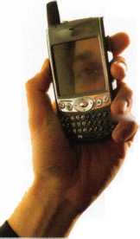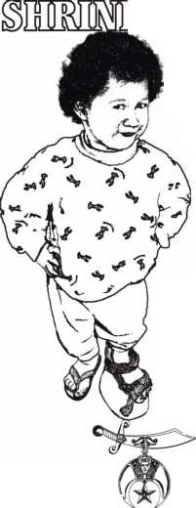

A Townhouse Complex Complex Problem

By Robert Schuetrumpf, CRL

**10**

Keynotes • April 2005

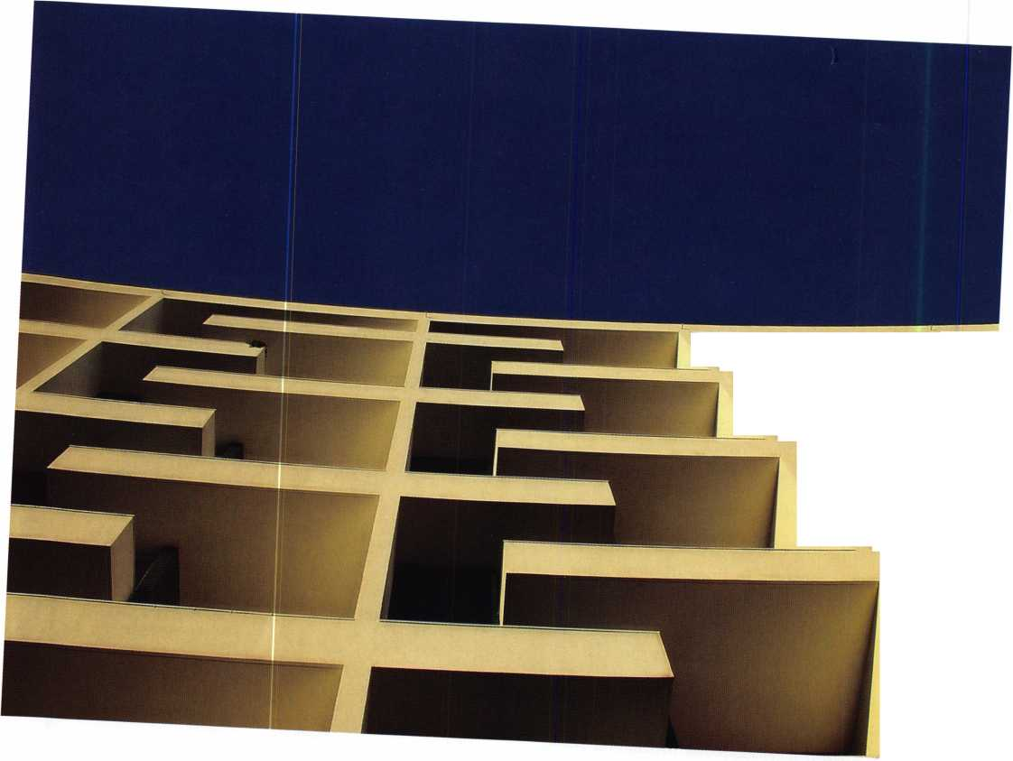

One complex in particular has been a constant problem since it was constructed.

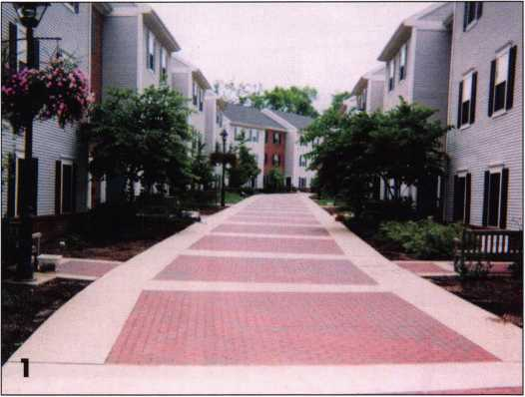

After starting as a locksmith last year at the College of New Jersey, I spent the first few months learning the layout of the campus and getting acquainted with the locking sys­tems. In late May, 2003, our electronic technician was called to active military duty in Iraq and I was suddenly thrown into the position of maintaining the electronic access systems on campus.

At the college, we have three townhouse-style resi­dential complexes (photo 1). Of the three, one com­plex in particular has been a constant problem since it was constructed. The one in question was the only complex that had magnetic hooks and exit devices with a request-to-exit switches installed (photo 2a &

2b) and used as the primary means to secure the entrance doors. These doors are, unfortunately, the only way to enter each apartment building.

The main problem with the complex was that any time there was a fluctuation of the electrical power to the complex, the maglocks and control boards would freeze. This created a lockout condition in which no one could access the apartment, even if they had the privileges. If no one was in the build­ing, the only way to gain access was to shut the power off to the building. After that, the memory in each affected control board had to be cleared.

Then the power was reapplied and a download of new information was sent to the control board.

Correcting these problems wasted countless man hours, much of which was considered overtime. It was a great deal of aggravation for our department,

as it took as long as four hours to make the buildings accessible again, depending on the number of apartments that were involuntarily locked down.

I was sent to find a solution to this problem, but found even more problems. Upon inspection of the fourteen

**New!** Keedex Stainless Steel Armored Door Loops

ALL

STAINLESS STEEL  
DESIGN

FLEXIBLE STAINLESS  
STEEL CONDUIT

STAINLESS STEEL  
END PIECES

STAINLESS STEEL  
MOUNTING SCREWS

COSTS NO MORE  
THAN MOST DOOR  
LOOPS THAT HAVE  
PLASTIC END PIECES

AVAILABLE FROM YOUR  
KEEDEX DISTRIBUTOR **Call or write today**

for yourfree catalog!

Keedex, Inc.

12931 Shackelford Lane  
Garden Grove, CA 92841  
714-636-5657 • Fax: 714-636-5680

. . e-mail: [info@keedex.com](mailto:info@keedex.com)

Ideas That Work **[www.keedex.com](http://www.keedex.com)**

MADE IN U.S.A.

Keynotes • April 2005

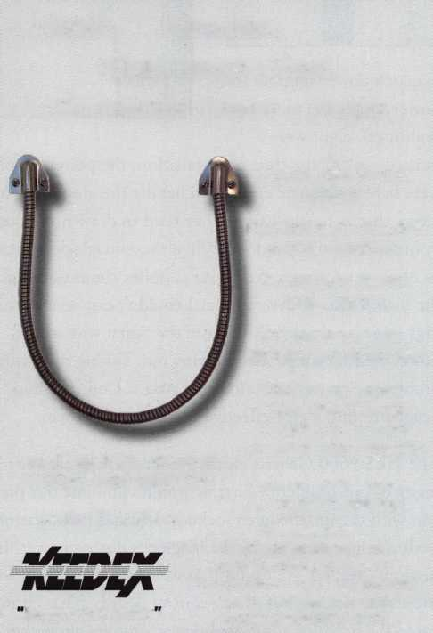

maglock power supplies (one power supply for every two buildings), eight were burned out. At the time of installation, the power supplies were barely adequate enough to handle the amp load. It seems that as maglocks age, they tend to draw more power in order to secure the door. When these maglocks started to draw more power, the power supplies could not handle the load. I also discovered that I couldn’t exit several build­ings on some occasions, because the signal wire in the power-transfer hinge was shorting out. Taking these other problems into consideration, the Access Control Shop needed to find a cost-effective way to correct them.

The HES 9600 Genesis electric strike was the answer to many of our problems. First, it would eliminate our prob­lem with the unscheduled lockouts because there was no feedback being caused by the maglocks during power fluc­tuations. Second, we found that we could power the elec­tric strikes directly off of our control boards. That elimi­nated the need for additional power supplies altogether.

Last, the HES 9600 allowed us to use the exit device strict­ly in a mechanical fashion without reliance on the device’s request-to-exit feature to release a maglock. Now, all I had to do was remove the maglocks, run some new cable, and install the electric strikes.

For each door (twenty nine in all), the first steps were to remove the maglock, drill the holes for the strike, and run a wire from the old magnet location to the new strike. I had already determined I could use most of the existing wiring with a minor reconfiguration from the old power supply to our reader board. I removed the existing strike (photo 3), cut the weather stripping (photo 4), applied my template (photo 5), marked my holes, and drilled two holes with a #7 drill bit (photo 6). I then tapped them for ? 20 bolts, and drilled a ?-inch hole for the wiring harness (photo 7).

I also needed to remove a small corner molding (photo 8) and drill a hole so I could fish the wire down the frame (photo 9). I accomplished this using a tool called a Wet Noodle made by Labor Saving Devices. This tool consists of a ten-foot piece of chain and a flexible rod with a magnetic

**2**

Keynotes • April 2005

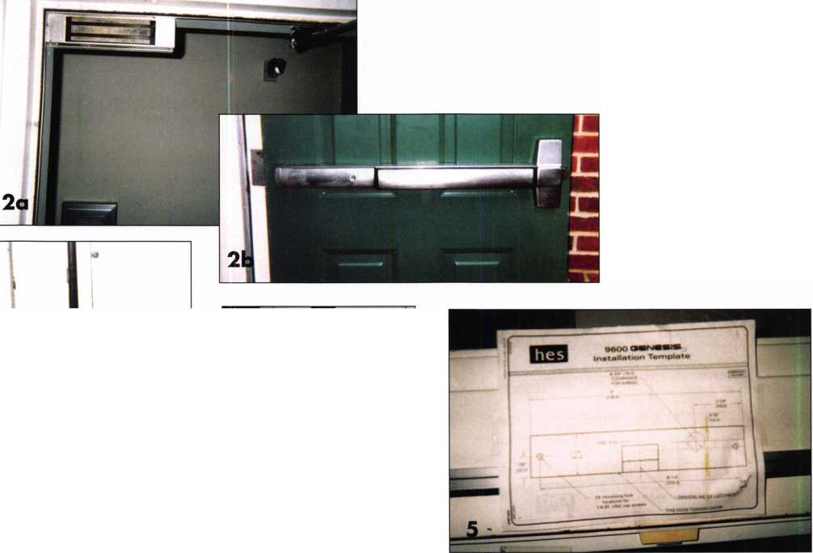

CALL 41 **1-800-355-6322** For More / „ Information ^

Professional Business Products

We donate **5**% of all sales to the  
**ALOA Scholarship Fund**Buying front NEBS®?

We offer tower prices on invoices/workorders, checks,  
repair tags, magnets, business cards, key tags and more.

www41bp2000.com

I completed the remaining twen­ty-eight buildings in about two weeks’ time.

Except for a few minor strike adjustments, there haven’t been any problems with these doors.

Using the HES 9600 saved the college thousands of dollars in parts, emergency call ins, and future maintenance.

I would highly recommend using this strike.

**ADVERTISE WITH  
OUR**

**WEATHERPROOF**

**LABLES**

end. I completed my wire connec­tions (photo 10), tucked the wires back into the frame, and reinstalled the molding. All that remained was to connect the wires, bolt the strike to the frame, and make final adjustments (photo 11).

Keynotes • April 2005

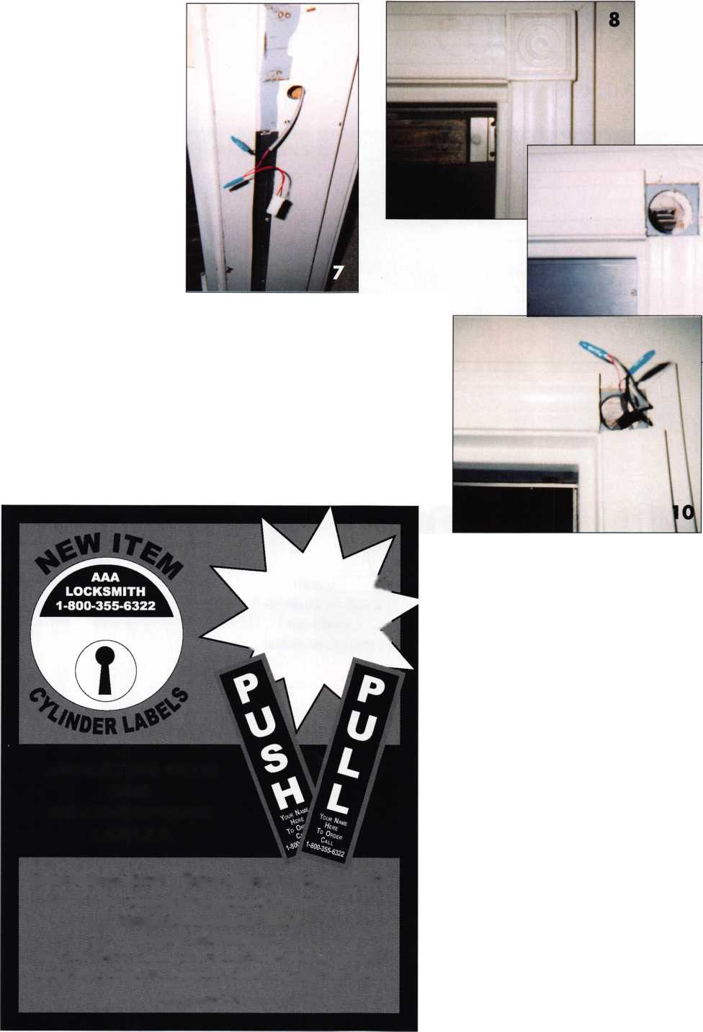

Safetech 2005

By: Greg Perry, CML, CPS



Keynotes • April 2005

rtt

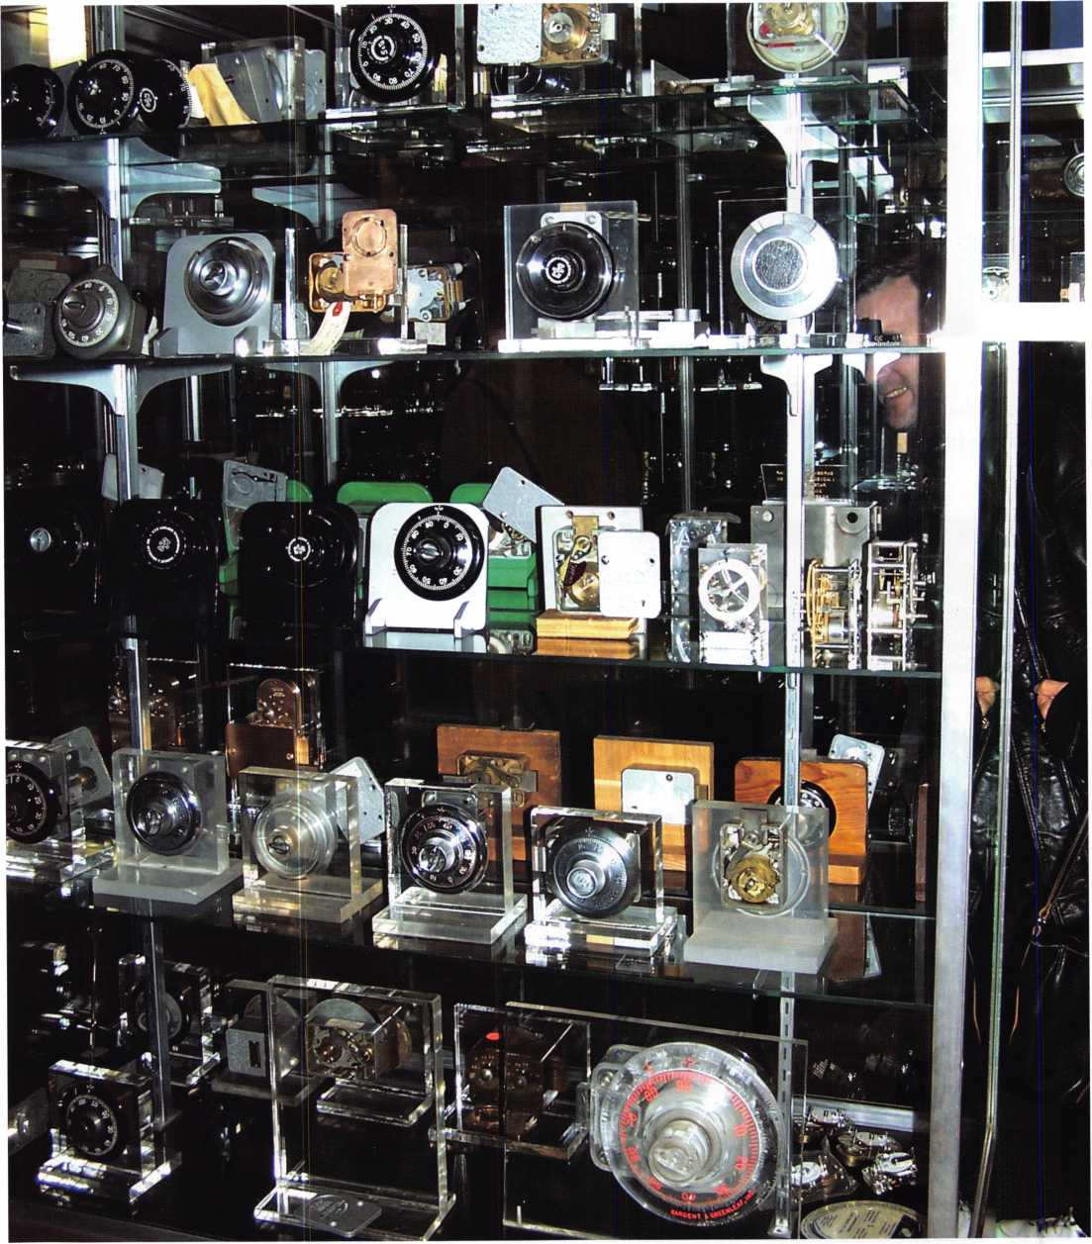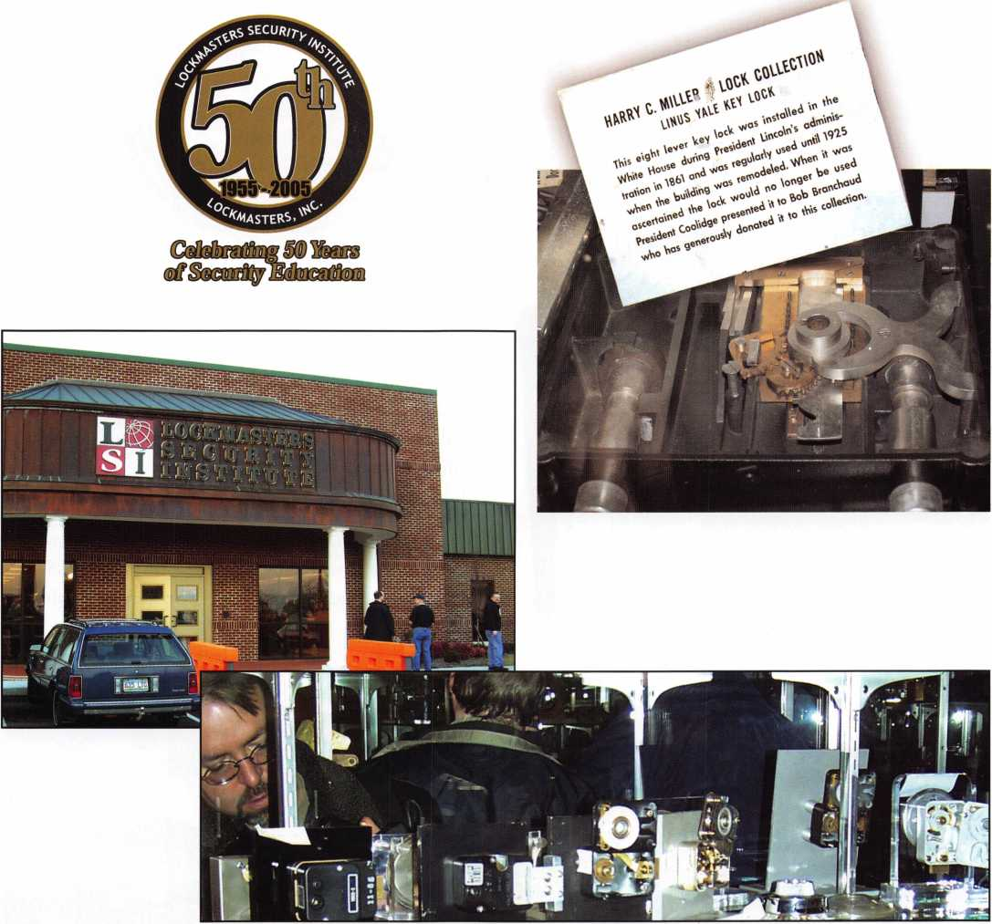

WOW-what a great convention! If you were not in Kentucky for the 2005 Safe and Vault Technicians Association con­vention, you missed a great opportunity. The information exchanged and networking gained by meeting with some of the greatest safe crackers was invaluable. The parties hosted by Lockmasters were second to none. This year was Lockmasters 50th anniversary. Clay Miller, and his son Mark, owners of Lockmasters, pulled out all stops. The party was held on Friday night at the new LSI building in Nicholasville, home of the Harry C. Miller lock collection.

The evening started with a bus ride from the hotel/convention center to the Kaba Mas offices in Lexington. We toured the plant and it was interesting. However, the real treat of the evening was the dinner party at LSI. The front lobby was filled with approximately a third of Harry Miller’s lock collection. During his lifetime Miller amassed what is believed to be the world’s largest collection of safe locks. It’s a collection worthy of envy, available for all to enjoy. If I didn’t have any

Keynotes • April 2005

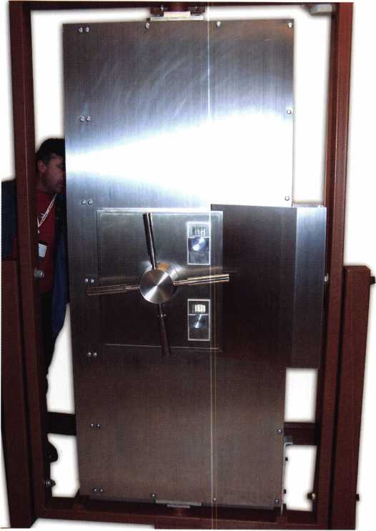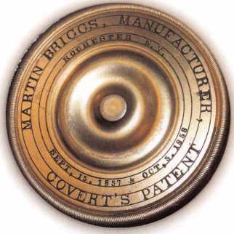

other reason to visit Kentucky, the exhibit in the lobby  
was worth the expense of the trip. I don’t get to see  
many of the pre-1950’s safes, and Miller’s collection  
allowed me to see many vintage and antique examples  
that are nonexistent or obsolete today.

The new building houses several classrooms dedicated  
to different aspects of the craft of the locksmith trade.  
One of the most interesting classrooms was the GSA  
and bank servicing classroom. There were GSA safes I

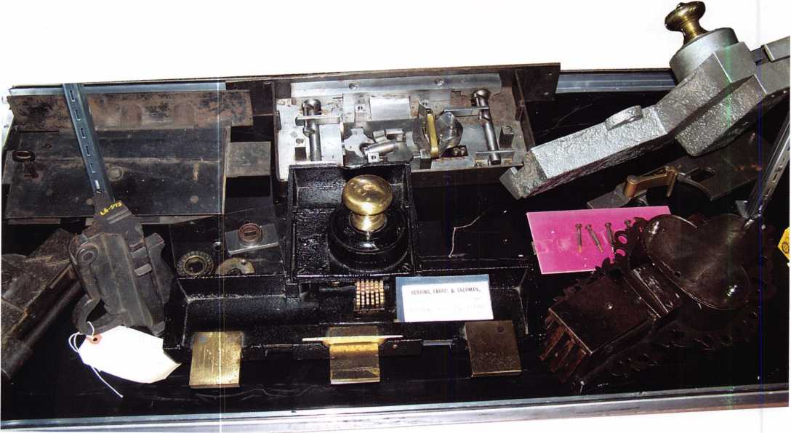

Keynotes • April 2005

**LOCK THE VOTE!**



Don't miss your chance to make your  
vote count. How? Cast your ballot in  
this year's ALOA elections. The ballots  
will be included in next month's issue of  
Keynotes. Simply fill out the proxy form  
and mail. The state of the Association  
depends on you.

★ NEW ★

This year, it's even easier to make  
a difference with Online Voting!

If you are voting online,  
you MUST REGISTER  
prior to May 9th at  
[www.aloa.org/vote](http://www.aloa.org/vote)

**Don't just follow the crowd*.♦  
YOUR VOTE can make a difference!**

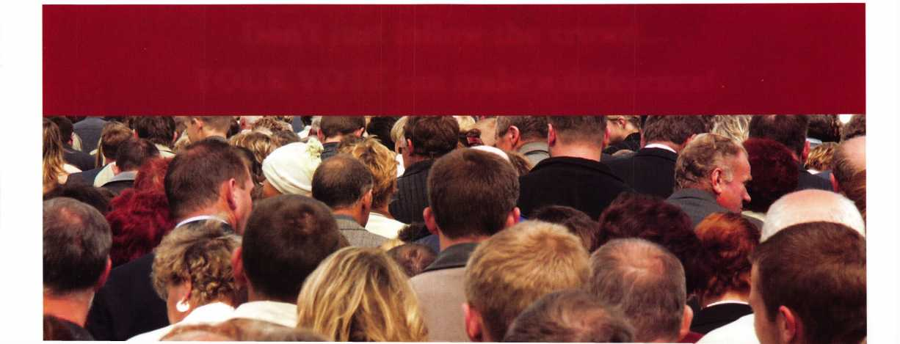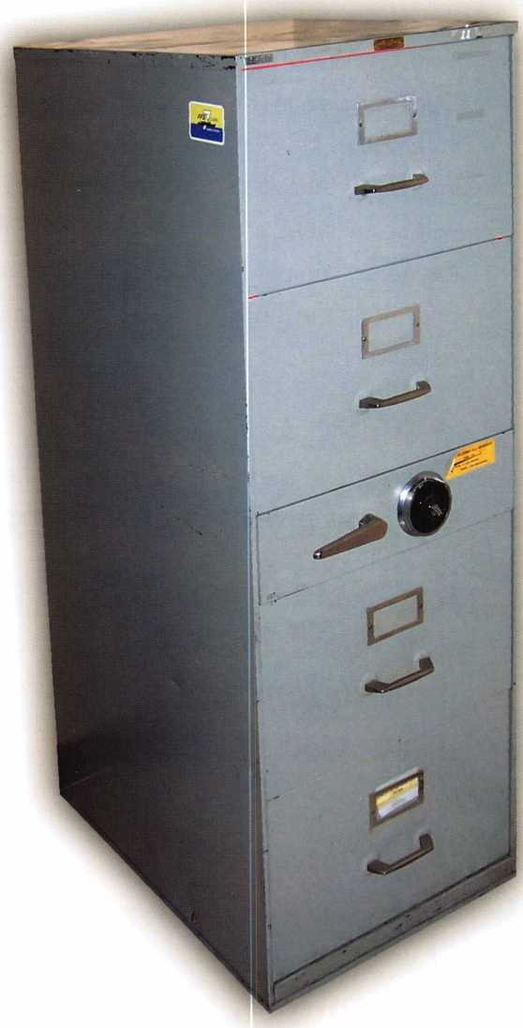

had only heard of from Hillside to Norfolk.

Some of these cabinets are extremely rare, as well  
as old, and they are still approved for use by the  
government. What was especially interesting was  
Vaughn Armstrong, who is considered one of the  
worlds leading authorities on GSA containers,  
was standing next to one and saying a few words  
about the safes as I snapped a few pictures. He  
explained that there were two different versions  
of this file safe produced by the Norfolk Naval  
Shipyard. One was referred to as “Inky” the other  
as “Stinky”. The entire safe, including the draw-  
ers and the area around the lock, is encased with  
a “foil” or sheet metal ‘sandwich’ that looks a lit-  
tle like a metal toaster pastry. Inside the sandwich  
is either a dye that leaks out if disturbed, or a dye  
with a smelly gas that vents when disturbed;  
hence, an inky version or a stinky version. In  
short, if one ever has to drill into one of these  
units, the safe is ruined.

Lockmasters also hosted the Saturday night din-  
ner banquet at a historic home outside of  
Lexington. The food was fantastic and the net-  
working continued. Ron Snively, President of

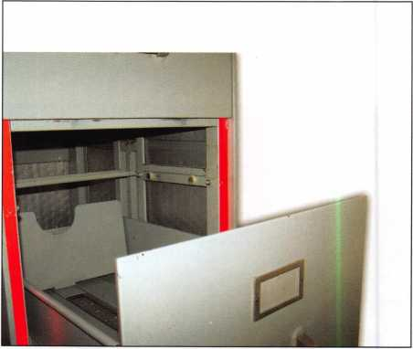

Keynotes • April 2005

Lockmasters more than deserves a huge thank you for hosting  
their own anniversary event. They provided the safe technicians

with two great parties in addition to much needed help  
throughout the week with classes, materials and logistics to  
make the 2005 SAVTA convention one of the greatest con-  
ventions ever. A very special thank you from me and many

others goes to the Miller family for allowing Harry’s collec-

tion to be seen and enjoyed by so many safe technicians.

SAVTA, presented Clay Miller, the son of Harry C. Miller, a copy of TruCenter: The Harry C. Miller Story, by A. M. Davis (see the review of this book on page 22).



Keynotes • April 2005

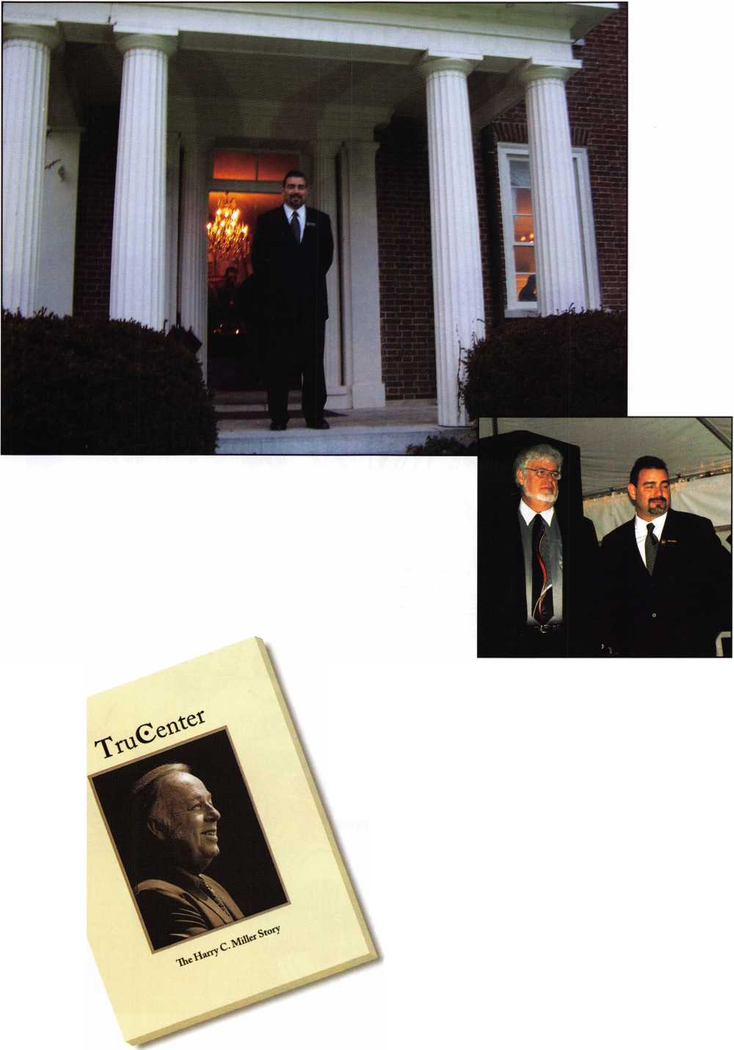

Keynotes • April 2005

K>

O

This is where I begin to see

the future, a future where locksmiths

may become obsolete.

w

H

m

on

r-t

rt>

3



What is a Locksmith?

I have watched the electronic industry take hold of much of what used to be considered the locksmith industry.

I am a big fan of science fiction writer Ray Bradbury and his book, Fahrenheit 451. In this story, he took me to see the future where firemen didn’t put out fires, they burned books. Even the houses had to be made of non-flammable materials, and the old homes were condemned, forcing their owners into the newer structures.

The locksmith industry is very similar to that story. I start­ed out in the 70s learning how locks were put together so that I could figure out how to defeat them: pick them, impression a key to take the place of one that may have been lost, or completely disassembling them to change the combination so that an existing key could no longer operate that particular lock. Over the years, as my skills improved, locking mechanisms improved. However, I felt confident that my abilities as a locksmith would match any competitor. I had the sense of pride that I was a fairly good locksmith.

As the lock manufacturers began migrating from mechani­cal operations to electronic mechanisms, some systems worked side-by-side, much like the transponder keys in many of todays automobiles. In changing with the times,

I not only had to figure out which mechanical combina­tion would permit the key to turn within the lock cylinder, I also had to match wits with the electronic package that controlled the vehicle’s computer. The mechanical side was second nature to me. The electronic side was a little differ­ent. I now had to tie into to the vehicles’ computer with special electronic transponder equipment, which hooks up to a vehicle’s computer, and permits access to complete

the programming for the vehicle to start. In the past,

I used to make about $35.00 to fit a key that would make a Ford F-150 churn to life. Now I make more than 4 times that to fit the original plus one duplicate, along with the programming.

This is where I begin to see the future, a future where lock­smiths may become obsolete. I have watched the electronic industry take hold of much of what used to be considered the locksmith industry. The job skills that made it possible for me to make a very decent living appears to be moving to the museum next to the dinosaur exhibit. Instead of a tool box that has a Swiss #4 impression file it now has a software program or optical scanner. A thorough knowl­edge of mechanical systems was, and to an extent, still is, important as more and more information in the present is electronically based.

I used to think that “sidewinder” keys, or Medeco high security locks were the future. I was mistaken. Those are Jurassic in comparison to the electronic gadgets out there now. The newest cars have no keys. Its all electronic, from disabling the door locks to starting the engine. If I had not seen what the future could hold, then this concept would have troubled me more than it does now. I have no desire to become an electronics wizard, there are enough of the old fashioned locks to keep me in business a while longer.

I guess I am part of the past, wondering if Linus Yale and Hank Spicer will let me sit down on the bench to rest my bones when I put away my tool box.

Keynotes • April 2005

**21**

TruCenter

The Harry C. Miller Story Reviewed

By: Greg Perry, CML, CPS

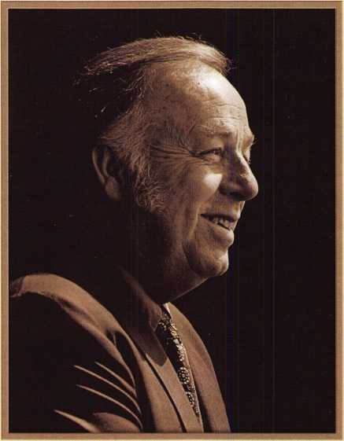

TruCenter

The Harry C. Miller Story

Keynotes • April 2005

Have you ever heard of a man named Harry C. Miller? Unless you’ve been hiding in your shop or a newcomer to this industry, especially the safe industry, you’ve undoubt­edly heard of him. Even if you’ve never heard of Harry, you’ve probably benefited from Harry’s life on this planet. Chances are good you’ve worked on or used some of Harry’s inventions. “TruCenter The Harry C Miller Story” by A. M. Davis is more than just an ordinary biography.

It details not only Harry’s life but also a history of safe lock collecting, Harry’s favorite pastime. This book introduced in Lexington Kentucky at the Safe And Vault Technicians convention last month is a must read for anyone in the lock and safe industry.

A.M. Davis details many of Harry’s exploits and relates stories from many sources including Harry’s family, former employees, and friends. The book details how Harry went from rags to riches inventing a manipulation-proof lock, selling the idea to the government and convincing Sargent and Greenleaf to manufacture the lock. In the process he acquired enough stock and capital to purchase the company in a few short years.

Around the same time, Harry founded Lockmasters and worked with some of the other industry greats getting ALOA found­ed. Harry taught one of the first safe classes in the late 1960’s with Bob McCown at an ALOA convention. At that time the primary way to learn the safe industry was from family.

Harry’s love for teaching did not stop at the classroom door, or even with just safes and locks. Harry’s love for teaching extended to the neighborhood kids and anyone with an interest. Many of the stories about Harry will put a smile on your face.

If you’re in the safe industry the book contains a wide range of safe lock pictures from Harry’s personal collection. This section is worth the price of the book alone. From pictures of both the Sargent Automatic and the Magnetic to MacNeale and Urban and the Herring Grasshopper the author catalogs a nice selection, but only a small fraction of the collection. She even has some pictures of the salesman’s samples of cannonball safes.

I purchased the book originally for the pictures, but on the airplane ride home, started reading the book. If you’re in this industry I think you’ll find it fascinating to read about a man who is probably the greatest legend in the modern safe world and perhaps of all time.

Get TruCenter and other  
great titles at the  
ALOA Online Store  
**http:/7wvsnv.aloa.org/store/**

Just a Few of Our Titles...

Learn About Basic Electricity 29.95

Spacing and Depths, vol 1 19.95

Spacing and Depths, vol 2 19.95

Filing for Dollars 29.95

Antique Padlocks 29.95

VATS Made Simple (Revised) 29.95

Guide to Transponders 79.00

2000 Transponder Update 45.00

Bread & Butter 85.00

Locks and Lockmakers of America 19.95

Learn About Electronic Locking Devices 29.95

The Best of Locksmithing, vol 1 19.95

Logical Lock Diagnostics 29.99

How to Pick Lever Locks 19.95

Fundamentals of Master Keying 55.00

Guide to Electronic Locksmithing 39.95

Security Solutions Locksmith

Marketing Program 89.95

The Ultimate Techtips Collection 39.95

PRP Resource Guide 25.00

Locksmithing from Apprentice to Master 27.00

Wafer Lock Reading 19.95

Door Lock Encyclopedia 39.95

Lock Repair Manual 14.95

Interchangeable Core Cylinders 34.95

Picking & Impressioning 45.00

The Lure of the Lock 29.95

High Security Safes, vol 1 175.00

High Security Safes, vol 2 175.00

Safeman's Guide, vol 13 9.95

Safe Deposit Depth and Space Manual 99.00

Safe Technician's Reference Manual 155.00

Gun Safes 110.00

Modern Safe Opening 59.95

Dave McOmie on Vault Doors, vol 1, Bank Vaults 1 10.00

Dave McOmie on Vault Doors, vol 2, Fire and Plate Vaults 110.00

Modern Safe Locks 95.00

Drilling Safes 95.00

Safe Deposit Box Service 39.95

Foreign Car Impressioning Book 29.95

Impressioning Ford and GM Side Bar Locks 29.95

Automotive Lock Servicing Update #1: GM 10-Cut Locks....29.95 Automotive Lock Servicing Update #2: GM 10-Cut Locks....29.95

Automotive Lock Servicing Update #3: GM 8-Cut Locks 29.95

GM Locks: Perfect for the Beginning Locksmith! 29.95

Ford Locks: Pin Tumbler and Ten-Cut Systems 29.95

Chrysler Pin Tumbler Locks 29.95

Chrysler Double-Bitted Locks 29.95

Toyota Split-Tumbler Locks 29.95

Basic Door Panel Servicing 29.95

Keynotes • April 2005



The Magic of Spherical Keying Revisited

By: Eric Costley, CRL

**24**

Keynotes • April 2005

**If**

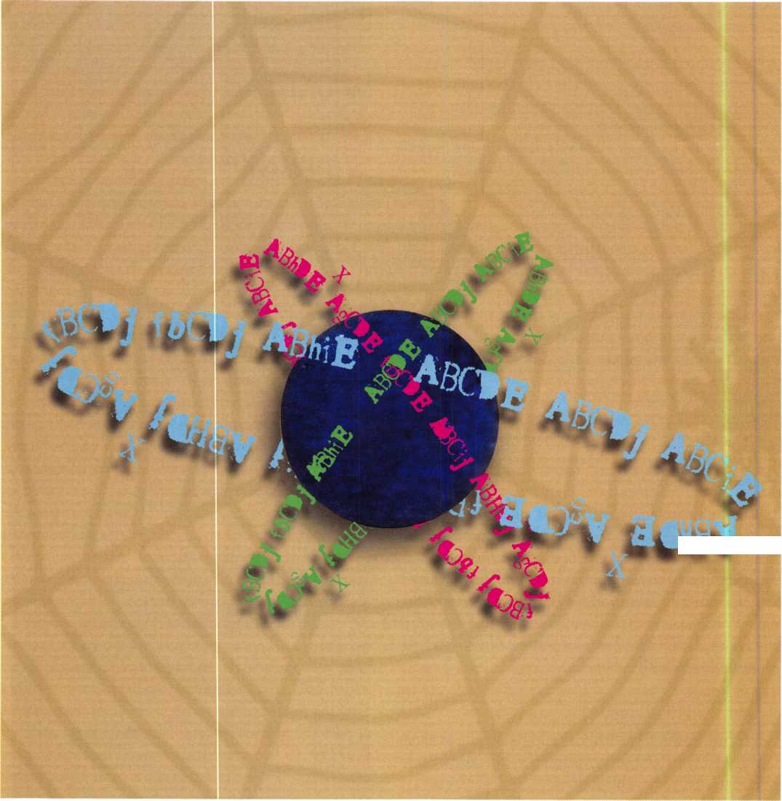

Just when we all thought that the uses of spherical Master keying had been exhausted, a few new quirks emerged from some e-mails and conversations that have proven that the use of the sphere is even more flexible than we original­ly thought. For those of you who are unfamiliar with the topic or might need a refresher course, the original discus­sions of the topic occurred in the November 2003 and June 2004 issues of Keynotes. A quick look back at these will help you move onward as we dig a little deeper.

Over the past year, my name seems to keep cropping up in other trade magazines, and not always in flattering terms. I must reiterate at this time that I did not invent the mathe­matical equations or relationships that exist between keys and their respective cylinder pinning, I have simply tried to expand our understanding of a very complex matter. Everything I have said about master keying was already there for our grasp, generations before I decided to dip my hand into the spider cage. All I ever attempted was to com­bine the ideas of Maison keying with master keying, which gave me a nice, small, easy to grasp tool that would allow me to accomplish extensive cross-keying without inter­change or stacking master wafers. Did I invent this? Certainly not. But the lack of printed material concerning cross-keying, combined with the demands of my cus­tomers, forced me to grasp, name, and publish what little contribution I have made.

Many have said that what I am doing is simply pointing out incidental masters. Well, exactly! What I am attempt­ing to do is to give the average Joe a nice little tool that they can plug into a standard full progression masterkey system so that they can accomplish whatever outrageous keying that their customer requests. The fact that I gave it a name and some guidelines seems to have upset some of you. While it is true that all of the keys in a spherical sys­tem exist as incidental masters in a full-blown full progres­sion system, it is much easier to extract a Sphere from your system than it is to print out an entire system to find the block, row, column and page masters that are the basis of spherical keying. By using the binary method, (in other words, there are only two possible key depths in any given position: either the masterkey cut or the change key cut,) we have managed to extract from a much larger masterkey system a large chunk of incidental masters without cross­keying into the remainder of the system.

The sphere is not a normal masterkey system. Once again,

I must reinforce that it is a derivative of Maison keying. The initial idea was to take a Maison system, and to make one key a master in the system. My definition of a Maison system differs from some of the definitions in print at this time. It is my understanding that by cross-keying a single 5 pin cylinder to two distinct keys, one can extract 32 keys that operate that cylinder, without the presence of a "mas­ter key". My personal monkey wrench is the presence of a master key, which creates a hierarchy of incidental masters that pose a quandary to most of us. By listing the keys and their relationships, I have made a small attempt to stick my pointy boot into the delicate rear end of the industry.

Originally, the sphere was developed for 5, 6, and 7 pin systems. In the beginning we thought of these as "stand alone" enigmas, until a customer of mine asked for even more outrageous cross- keying, which resulted in a "sand­wich" between a classical system and a sphere. By using the top masterkey as key 1 and extracting the last key of the sphere from the bitting array, we have created parallel sys­tems which are operated by the same masterkey with no possible interchange, except that which is intentionally implemented via the sphere. As I know that the whole process leaves many people scratching their head in frustra­tion, we will use this particular example to illustrate the ease of spherical keying later on in this same article.

One of the first questions that I fielded concerning my articles concerned the use of multiple spheres extracted from the same classical bitting array. If, (in a six pin sys­tem,) there are four possible variations in each pin position of a standard bitting array, you can theoretically extract four separate spheres with a potential 20 individual change keys under each separate sphere. In an institutional appli­cation, (such as a group of four dormitories at a college,) if you needed 20 individual change keys which each operated the exterior doors of that particular dormitory and the individual dorm room, one masterkey could operate all doors, and each of the spherical change keys would operate only common doors and the individual rooms. In addition, cleaning personnel or maintenance people could be given a key which was building specific, using keys from the upper levels of the sphere.

The nature of spherical keying tends to lean toward appli­

**25**

Keynotes • April 2005

cations which are primarily institutional. Other than this, it is primarily a tool used to create extensive cross keying without stacking master wafers in locks, making the system not only more secure, but less prone to malfunction and wear due to less moving parts in any given cylinder.

Smaller spheres can be extracted for smaller projects, too. One can generate a 3 pin or 4 pin sphere, although the smaller size automatically limits the number of individual change keys to just a few.

In review, a 5 pin sphere breaks down to 32 keys, grouped as follows: 1,5,10,10,5, and 1. A 6 pin system: 1,6,15,20,15,6, and 1. A 7 pin system breaks down to 1,7,21,35,35,21,7, and 1. In the event that you need even fewer individual change keys, a 4 pin sphere breaks down to groups of 1,4,6,4 and 1, (yielding only 6 individual change keys,) and a 3 pin sphere breaks down to groups of 1,3,4, and 1. With a 3 pin sphere, you have only 4 individ­ual change keys. In a six pin system, it is conceivable that you could use the first 3 pins, and then the last 3 pins, and generate 8 individual spheres... with no possibility of interchange!

At some point, in the future, I intend to generate spheres in the manner of a rotating constant, where spheres over­lap, and masters cross into other spheres.. .but until that fine summer day arrives, I can only hope that you drool at the possibility.

In an attempt to relate a "real life" example, I will present the puzzle that a customer asked me to solve, and my "spherical" solution to the quandary, which has, (at this point in time,) been in place for over a year with no glitch­es, other than those cleverly inserted by the customer once the system was up and running.

In addition, the first spherical masterkey system is still up and running some two years hence, despite four separate calls to make changes in the system. (Of course each time this customer calls, we all cringe, but so far... so good!)

As for the promised example, some background is probably appropriate. I received a call from a local church, and the individual in charge seemed more knowledgeable than most of my customers concerning his wants and needs. When I arrived at the church for the initial walk-through,

I found out that he had managed the keying systems in a

**fiRCya L S ta T iqn _** sxiniM nrmm#

» - ***&&**«*#\**** § - ***hjxsfmtmds >*** *

EnarRaa

large commercial setting before he had retired, and his gen­eral demeanor and basic understanding of masterkey sys­tems set me immediately at ease. As we walked through the building, (with a carefully designed floor plan, I might add,) the job initially looked as if a standard full progres­sion system might accomplish the desired keying. Also, the exterior doors were to be keyed on a separate change key, which bolstered my spirits.

It was when we moved to the large open area under the sanctuary that things got complicated.

Jim grinned as he explained that there were several group which shared many rooms in the area, including Boy Scouts, a daycare center, the Sunday School, and a com­munity group. At this point, the colored highlighter pens come into play.

I should pause here to say that when you are designing a spherical masterkey system, a pack of at least six high­lighter pens is a must. In this manner, you can designate "groups to rooms". If you have a floor plan of the building, simply make a colored dash in the room which represents the group (or groups,) which must have access to the room. A few of the rooms in this system required four dis­tinct colors to show the desired keying... and even that got amended before the system was finally in place.

As we walked from room to room, I made extensive notes concerning who was to have access to each individual area. By the time I strolled out to the van, I was pretty sure that

Keynotes • April 2005

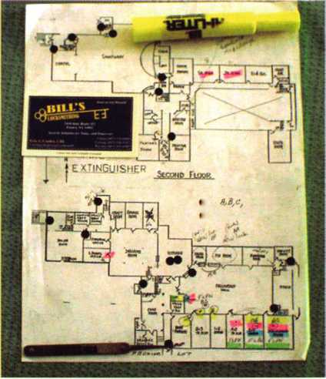

I could do this using spherical masterkeying, but the num­ber of individual change keys needed was far too large for the 5 pin system that was in place. (Remember, a 5 pin system only yields 10 individual and autonomous changes!) It was at this point that I designed the "sandwich" between a classical system and a sphere.

I will be using some theoretical numbers here, and disguis­ing the identity of the actual customer to further protect the integrity of the actual system. No matter how you slice it, it still works. Put your thinking caps on!

Let's say that the customer is on a five pin Corbin Russwin pre-system 70 system, which gives us 10 depths to work with, 0 through 9. Arbitrarily, we have picked our mas- terkey to be cut to 47213. From this point, we generate our initial "full blown" bitting array, which would be as follows:

Masterkey: 4 7 2 1 3

Bitting array: 2 14 3 1 63 6 3 5

1. 5 8 77 0 9 0 9 9

At this point, we have everything we need to generate a classical masterkey system. Now, in order to generate a sphere, we extract the bitting of "key 32" from our bitting array, which will allow us to generate a sphere, and leaves the remainder of the bitting array available for use in stan­dard masterkeying. If we designate "SP32" as 83677, the remainder of the bitting array is as follows:

Masterkey: 4 7 2 1 3

Extracted for

sphere: 8 3 6 7 7

Bitting array: 2 14 3 1

6 5 8 5 5

1. 0 9 9

For this particular system, I only needed a total of 15 indi­vidual fully progressed change keys. For our example, they will be designated as follows:

|  |  |  |
| --- | --- | --- |
| A1: 2 1 4 3 1 | A6: 2 1 4 5 9 | All: 2 1 8 3 9 |
| A2: 2 1 4 3 5 | A7: 2 1 4 9 5 | A12: 2 185 1 |
| A3: 2 1 4 3 9 | A8: 2 1 4 9 9 | A13: 2 1 8 5 5 |
| A4: 2 1 4 5 1 | A9: 2 1 8 3 1 | A14: 2 185 9 |
| A5: 2 1 4 5 5 | A10: 2 18 3 5 | A15: 2 18 99 |
| Are you ready? (Things are about to get as hairy as a taran­tula!) Now, using the extracted key from the original bit­ting array as key 32 of a sphere, and our existing masterkey as key 1, we generate our sphere, as follows: | | |
| SPl: 4 7 2 1 3 | SPl 2: 4 3 2 73 | SP23: 8 3 2 7 3 |
| SP2: 4 7 2 1 7 | SPl3: 8 72 73 | SP24: 8 3 2 1 7 |
| SP3: 4 7 2 7 3 | SP14: 4 3 6 13 | SP25: 8 7 6 1 7 |
| SP4: 4 7 6 1 3 | SPl 5: 8 7613 | SP26: 4 3 6 17 |
| SP5: 4 3 2 1 3 | SPl 6: 8 3 2 1 3 | SP27: 4 3 6 7 7 |
| SP6: 8 7 2 13 | SP17: 4 7 6 7 7 | SP28: 8 7 6 7 7 |
| SP7: 4 7 2 7 7 | SPl8: 4 3 2 77 | SP29: 8 3 2 7 7 |
| SP8: 4 7 6 1 7 | SPl9: 8 72 77 | SP30: 8 3 6 17 |
| SP9: 4 3 2 17 | SP20: 4 3 6 7 3 | SP31: 8 3 6 73 |
| SP10: 8 7 2 1 7 | SP21: 8 76 73 | SP32: 8 3 6 7 7 |
| SPl 1: 4 7 6 7 3 | SP22: 8 3 6 1 3 |  |

Now that we've generated our numbers, all that remains is to designate what goes where, and this is where the diffi­cult work goes in. I've included a photograph of my origi­nal diagram, (complete with highlights,) in order to help you understand how to use the sphere to your advantage. The 4 groups, (each represented by a different color,) are the Sunday School, daycare, Boy Scouts, and "FLPN". Notice that some rooms require all four groups to gain access, some are specific to only one group, and some are operated by either two or three of the groups. By looking at the colored markings I have made on the diagram, you can begin to decipher how one goes about choosing keys from the sphere. If there is a single color marking any one room, this means that it must have an autonomous change key. In a five pin system, we have 10 autonomous changes. The nice thing about a five pin system is that we can choose these changes from one or the other, (but not both simultaneously!) either from the groups consisting of keys

**27**

Keynotes • April 2005

|  |  |  |
| --- | --- | --- |
| SP1 | ABODE | key 1 |
| SP2 | ABCDj | keys 1,2 |
| SP3 | ABCiE | keys 1,3 |
| SP4 | AbhDE | keys 1,4 |
| SP5 | AgCDE | keys 1,5 |
| SP6 | FBCDE | keys 1,6 |
| SP7 | ABCij | keys 1,2,3,7 |
| SP8 | AbhDj | keys 1,2,4,8 |
| SP9 | AjCDj | keys 1,2,5,9 |
| SP10 | fBCDj | keys 1,2,6,10 |
| SP11 | AbhiE | keys 1,3,4,11 |
| SP12 | AgCiE | keys 1,3,5,12 |
| SP13 | fBCiE | keys 1,3,6,13 |
| SP14 | AghDE | keys 1,4,5,14 |
| SP15 | fBhDE | keys 1,4,6,15 |
| SP16 | fgCDE | keys 1,5,6,16 |
| SP17 | Abhij | keys 1,2,3,4,7,8,11,17 |
| SP18 | AgCij | keys 1,2,3,5,7,9,12,18 |
| SP19 | fBCij | keys 1,2,3,6,7,10,13,19 |
| SP20 | AghiE | keys 1,3,4,5,11,12,14,20 |
| SP21 | fBhiE | keys 1,3,4,6,11,13,15,21 |
| SP22 | fghDE | keys 1,4,5,6,14,15,16,22 |
| SP23 | fgCiE | keys 1,3,5,6,12,13,16,23 |
| SP24 | fgCDj | keys 1,2,5,6,9,10,16,24 |
| SP25 | fBDj | keys 1,2,4,6,8,10,15,25 |
| SP26 | AghDj | keys 1,2,4,5,8,9,14,26 |
| SP27 | Aghij | keys 1,2,3,4,5,7,8,9,11,12,14,17,18,20,26,27 |
| SP28 | fBhij | keys 1,2,3,4,6,7,8,10,11,13,15,17,19,21,25,28 |
| SP29 | fgCij | keys 1,2,3,5,67,9,10,12,13,16,18,19,23,24,29 |
| SP30 | fghD | keys 1,2,4,5,6,8,9,10,14,15,16,22,24,25,26,30 |
| SP31 | fghiE | keys 1,3,4,5,6,11,12,13,14,15,16,20,21,22,23,31 |
| SP32 | fghij | Operated by all keys within the system. |

7 through 16, or from the group that consists of keys 17 through 26. Since 3 of the groups require a room that is autonomous, all of these keys are picked from the same grouping of keys. (Only the FLPN area and the janitor's closet were subservient to these, and therefore had to be picked from lower levels of keying.) An additional glitch was that the daycare specific rooms were not to be mas- terkeyed, although the same key that they were issued was to operate other areas which were to be masterkeyed! Using the sphere, this became the easiest of problems to solve. The 3 rooms that were specific to the daycare area were keyed only to the change key, while other rooms were keyed into the sphere in the usual fashion.

As I look back on the way I actually keyed this system, I see now how I could have improved the "flow" and conti­nuity of the system.... primarily by following some of the

recommendations I have just outlined! However, this was only the third system that I had implemented, and the first to incorporate a blending of both classical and spherical systems. (When you come up with something this outra­geous, its not like you can go ask anyone for help when you think you're getting in over your head!) In any case, if our illustrious editors would be so kind as to reprint the 5 pin listing of keys chart and the listing of "what fits what" from the November 2003 article for our continuing edifi­cation and convenience, I will continue to weave this little web for you.

While there were four key carrying groups to deal with, (ideally with one key each,) there are nine doors in ques­tion. As is, was, and always shall be the rule when cross­keying: work from the bottom up! Whichever door or doors represent the worst mess, start here, and work back-

**28**

Keynotes • April 2005

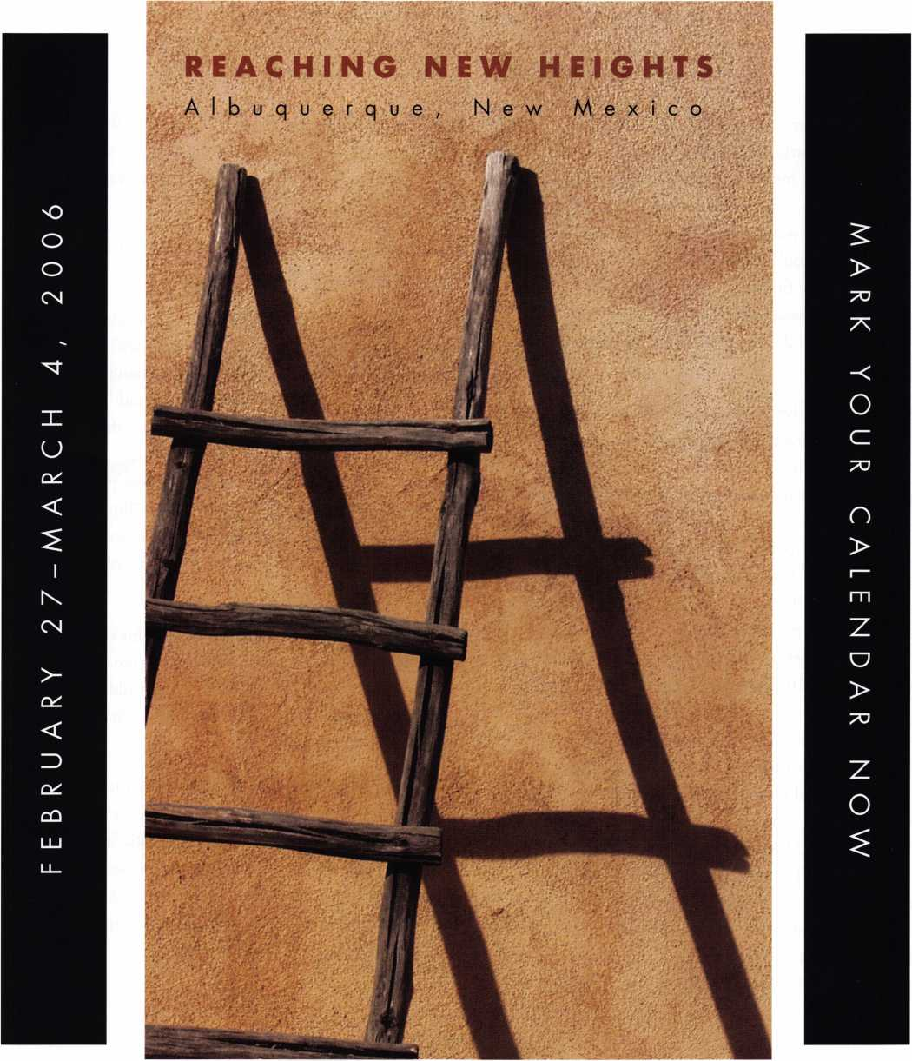

When it comes to learning about the latest in safes and vaults, time is of the essence. SAFETECH 2006 features an all-new menu of classes, covering every safe topic on the globe. Don't miss out!

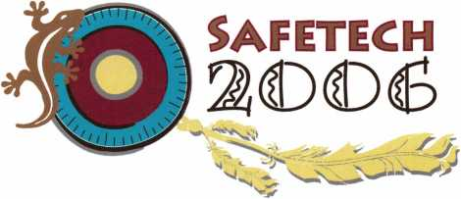

wards. It was obvious that the janitor’s closet was the worst case, to be fit by all four groups. Two other rooms, the 3rd & 4th grade room and the discipleship room could also be keyed like the janitor's closet. In order to leave myself "room to maneuver in the future" should the need arise, these rooms were arbitrarily chosen to be keyed to SP26. (This allows room for subservient areas in the next level down, and since no individual change key for these rooms was needed, SP26 was a keying designation more than any­thing else.) If we look at our chart of "what fits what" in a five pin sphere, we find that SP26 is operated by eight individual keys, (twice our needed amount,) keys 1,2,4,5,8,9,14 and 26. From these we must choose our four group keys.

It is important at this stage to keep your wits about you and minimize distractions. Of course, that's always good advice when devising a masterkey system, isn't it? Of the eight possible keys that we have to choose from, one is the masterkey. Another is SP26, which is the individual change key that fits these rooms, but that we don't need. Going back to our "what fits what", we find that our six remain­ing keys, (2,4,5,8,9, and 14,) fall into 2 distinct groupings. Keys 2,4,and 5 come from a higher group than keys 8,9, and 14. (Remember, in a five pin system, our grouping of 32 keys is 1,5,10,10,5,and 1.) Since the Sunday School key, (represented by the pink highlighter,) needed to fit the most rooms, I chose SP2 for that application. The daycare, (yellow highlighter,) had the next largest quantity of rooms, and needed to be independent from the Sunday School. Therefore, it needed to be chosen from either the same grouping as SP2, or from a lower level key that SP2 did not operate. (That's what you would think, right?) Actually, that is incorrect. Since the actual daycare doors are not mastered, we CAN choose a key from lower in the system which would, (if these locks were masterkeyed,) be operated by SP2. I chose SP9 for the daycare doors.

(Remember, whatever keys we choose for the remaining doors must operate SP26. Our original "picking pool" consisted of 2,4,5,8,9,and 14. We have now used 2 and 9. Only 4,5,8, and 14 remain.) At this point, we have only two keys left to choose: the Boy Scouts and the FLPN key. Since SP8 and SP14 come from the same grouping, they were chosen as the FLPN and Boy Scouts, respectively.

At this point, our puzzle is solved! All that remains is to cut the keys and to implement the system. A day later, everything was up and running...

Two days later I got a call from Jim. (I was obviously nerv­ous, since this was the first "sphere sandwich" that we had implemented.) "I'd like to make a little change, if it's pos­sible." he said. I crossed my fingers, and said "Go ahead, let's hear what you need." As it turned out, there were occasions when even more groups would use the reception hall, for weddings and such. Although these people would­n't need access to any of the other rooms, Jim thought it would be a good idea if they could at least access the 2 jan­itor's closets, in case there was a mess that needed cleaning up.

Of course, I immediately grinned. Sure, this could be done easily: it only required me to re-pin those two cylinders, (which were keyed to SP26,) to SP32. By adding two mas­ter wafers to each cylinder and cutting the change key, the job was accomplished.

There are still many more mysteries about masterkeying that we can explore, and in time I hope to be giving you more insights into this wonderful enigmatic world. In the meantime, take the time to familiarize yourself with the intricacies which I have already revealed, as they are but mere stepping stones to where I will be taking you in the future. In the meantime, happy keying!

**30**

Keynotes • April 2005



**RING of a KING**

Member Name Sponships

Kwok-kei Leung 222

Henry W. Raymond 92

Yuriko Yanai 82

Mary S. Ohmit CPL 66

Charles C. Robertson CML 65

William Lee CRL 56

Jack Hobin CPL 51

Clifford D. Lipscomb CML, CPS 47

Michael B. Groves 43

C Allan Halverson 40

David M. Troiano 40

Myeong-Rae Cho 38

Jim Williams CRL 38

David M. Lowell CML, CMST 36

Salvatore J. Dulcamaro CML 36

Dana L. Barnum CML 35

Barry K. Leas CRL 35

Danny W. Rudd CPL 33

William L. Young CML, CPS 33

Larry A. Warnick CML 31

Eugene R. Altobella Sr 31

Jeanne G. Lodge CML 30

Robert D. DeWeese CML 30

Ken Dale 29

John C. Elliott Jr, CML, CPS 28

Robert W. Duman Sr, CML 28

Scott L. Henke CPL, CPS 28

Dallas C. Brooks 28

William T. Beranek 28

Breck H. Camp CML 27

Lawrence F. Smith Jr, CML 27

Marian M. Swann CRL 27

James M. Watt CML, CPS 27

Anthony J. Ramunno CML, CPS 26

Jeffrey S. Nunberg CML, CMST 26

J Thomas Hood CML 26

John L. Shandy CML 25

Elvis D. Hammerschmidt CPL 25

Philip A. Rovenolt CPL 25

Jerome L. Cohen CML 23

Peter K. Gauthier CPL, CPS 23

Man-Soo Seo RL 23

James J. Cawby CML, CPS 22

James L. Hancock CPL 22

Hans Mejlshede CML 21

Peter Sarailian CRL 21

John S. Dorsey CML, CPS 20

Thomas G. Vandersteen CML, CPS.. 19

Walter W. Lascar RL 18

Keizo Takahashi CRL 18

James E. Fowler Sr, CML 18

David C. Harris CML 18

Ronald E. Heidzig 18

Joe J. Lee CRL 18

Takashi Kuwana CRL 18

Eugene R. Altobella Jr 18

Ernest W. Wright 17

Peter R. Hall 17

William P. Grant CRL 17

James E. Gruber CPL 17

Evelyn V. Wersonick CML, CPS 16

Joseph P. Ferrero CML 16

Gary F. Teams CPL 16

Kenneth E. Kim CRL, CPS 16

William J. McElheney CML 16

John W. Soderland CML, CMST ....16

Michael E. Jordan Jr, CML 16

Jon B. Griswold CML 16

Brian J. Reetz 16

John A. Ilk CRL, CPS 16

Russell P. Fuller CRL 16

Robert C. Rodocker CPL 15

John J. Greenan CML, CPS 15

Steve L. Cothron 15

Leonard J. Passarello CPL 14

Bruce J. Tarbet CML, CPS 14

John D. Cannon CML 14

Paul M. Souber 14

James T. Brickler CPL 14

Richard C. Sievers 14

Calvin G. Harris CML 13

Frank D. Hartung CML 13

Rolando Bouza 13

Timothy J. Moore CRL 13

John F. Engel CRL 13

Donald H. Shiles RL 13

Brooke P. Berry CRL 13

William J. Wickward CML 12

Raymond C. Lusk CML 12

Robert M. Massard CRL,AHC 12

Gregory L. Perry CML, CPS 12

Eric F. Veal 12

Barry L. McMenimon CPL 12

Thomas J. Demont CML, AHC 11

Basil W. Shannon CPL 11

Ralph O. Warren CML 11

Gordon R. Racine CML 11

Kevin R. Wilson CML, CPS 11

Timothy K. Chow 11

Michael C. Olson CRL 11

Dale L. Knowles CPL 11

Andrew A. Edmunds CML, CPS 11

Marian E. Sagar 11

Daniel S. Enriquez CRL 11

Gene Eldridge CPL 10

Ronald P. Riggins CML 10

Charles E. Haas CML 10

Robert E. Mock 10

Lester S. Brodsky 10

Larry L. Votaw CML 10

Thomas R. Smith CPL 10

Todd K. Ladwig CML, CPS 10

William T. Straub CML 10

Randy L. Hutchison CRL 10

Richard T. Johnson CPL 10

Vincent L. Formon CML, CPS 10

Carroll T. Croson Jr 10

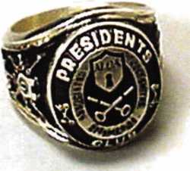

How can I join the President's Club?

You can earn a membership in this prestigious club by recruiting  
just 10 new members for ALOA.

*Any ALOA member may participate.

What do I get?

When you recruit 10 members, you receive a  
handsome blue blazer with a President's Club crest.  
For each additional five members you recruit, you  
receive a lapel pin with gold-filled numbers, indicating,  
your recruiting successes.

You also get the satisifaction of knowing that you are  
helping your association, helping your industry grow,  
and you are helping fellow locksmiths achieve success.

How do I get started?

Mail the form below to the ALOA office for a supply of applications (800) 532-ALOA or FAX (214) 827-1810. One President's Club credit is awarded for each new applicant. Credit is awarded only after the membership application is pproved. However, the credit will apply for the period in which the application is received. Failure to identify yourself as the sponsor on the applica­tion form at the time it is submitted to ALOA for process­ing will forfeit any credit.

|  |  |  |
| --- | --- | --- |
|  | Yes! 1 want to join the ALOA President's Club. |  |
|  | Please rush me applications so J can start earning credit toward membership in the club! |  |
| Name | | |
| Company | | |
| Address | | |
|  | State Zip |  |

Mail this form to ALOA • 3003 Live Oak • Dallas, Texas 75204-61 86

Another Trade Show-Be Smart!

By: Claire L. Cohen, CML

You’ve been asked to attend another trade show. Envious  
co-workers wish they could also “escape” from a day at the  
shop and attend. But is this really a day off? Trade shows  
may require pre-planning, extra hours to travel, and long  
day (or days) on the exhibit floor. Tired feet from walking  
miles, and aching arms from carrying tons of literature can  
make you feel anything but refreshed and revitalized from  
a day off at work.

Be smart! There are many things that attendees can do  
to make the experience extremely positive, rather

than an exhausting journey. Finding new  
products, the right products

for a job, and build-  
ing positive busi-  
ness relations can  
insure that your  
day (or days) away  
from the shop are  
well spent.

Pre-show planning can

help maximize your time  
on the exhibit floor. The  
most important task before  
attending the show is plan-  
ning how you will use the time

to achieve maximum benefit for  
you and your company. It’s critical  
to plan ahead. Are there certain  
suppliers you want to see to talk  
about new products, problems with  
existing applications, better pricing,  
etc? Can you squeeze in educational  
classes and seminars?

If you are in a conference center crammed with exhibitors,

make note of who you especially want to see and what you  
want to talk about. Your show directory can be more than

a just a map. It may contain a great deal of important  
information, such as schedules, seminars descriptions  
and supplier descriptions. If an exhibitor map is provided,  
circle where booths of interest are located.

Give yourself enough time to gain maximum benefit also.  
Travel the day before (if possible), and plan to leave after

the exhibit ends. Don’t cut your time too short.

Pre-register by mail if that is possible.

During the registration process, sched-  
ule yourself for educational classes  
and/or seminars. Convenient (you  
are already there), you could poten-

tially to pick up ideas from class-  
es/seminars that will save you  
time or add additional revenue  
to your business.

During the planning  
process, you may want to  
contact other attendees or  
exhibitors to schedule

breakfast, lunch or din-  
ner meetings.

Equip yourself for  
the show. Bring  
enough business

cards, business checks and busi-  
ness credit cards so that you can make

purchases onsite. Have a small notebook handy to  
jot down some quick notes.

Carpeted displays may look elegant, but beware of the con-  
crete floors just underneath the carpet. This can be a less  
than comfortable surface to walk or stand for extended peri-  
ods of time. Dress professionally—and remember your com-  
fortable shoes! Dress appropriately for the entire day as you  
may decide to go out to dinner or meetings (extended day).



Keynotes • April 2005

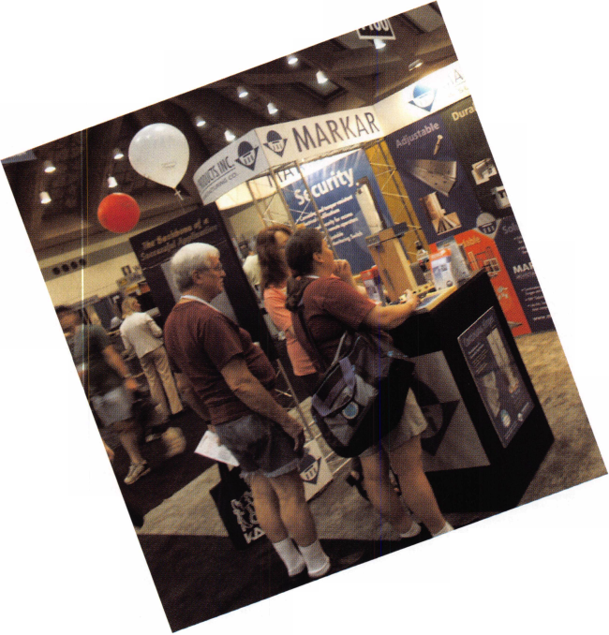

Starting the day right get some nutrition before the exhibit floor opens. Tempted by limitless exhibitors, you may not want to break for a full lunch. Or, you may find that you wont be eating again till the show ends in the evening.

The first day of the show has come. Arrive early—time to renew old acquaintances and make some new friends. If you need to register, do that before the show exhibits starts. Perhaps there will be a place to check your coat, rather than carrying it around all day. Take time to review the new product showcase for ideas/products that you can apply to your business.

Introduce yourself and talk about your type of business, and your business needs. Pay attention to individual names and company names on badges.

Loaded with catalogs, product samples, sell sheets...its hard to pass up any booth. Who knows, what we may need someday?! When you are on the show floor, be aware as to what materials you pick up. Often attendees take for the sake of taking—pounds of paper, brochures, and sam­ples. Remember, you have to carry everything you pick up!

Some exhibitors can arrange to have materials sent directly to you. They can have heavy catalogs sent, sparing you shoulder and hand fatigue. Ask manufactures if they have catalogs available on CD. Websites may contain product information just keystrokes away. Located in many large convention centers are mailing centers. At a cost, you can have packages of literature mailed directly to your business, leaving you “hands free”.

Break times are important too. During this time review your timetable. Are there exhibits or people you still need to see? If you have extra time, what other booths have you missed? Sit down for a couple of minutes, grab a snack, and chat with an old friend. This may help prevent show burnout.

Be sure to visit exhibit sponsor booth. Here you can find out the date for the next exhibit and plan for the fol­lowing year.

A trade show’s overall goal is to bring people together to do business. Be smart! With some pre-planning before the show begins, and some good show strategies, you can insure that your “day off” from work will be productive and beneficial for you and your business.

Pack your Bags!

Check the ALOA Calendar  
located at [www.aloa.org](http://www.aloa.org) for  
up-to-date information on  
these and other

upcoming shows

California Locksmiths Association  
Trade Show & Educational Program  
Ontario California

KDL Trade Show  
Seattle, Washington  
206-682-7383  
[www.kdllink.com/index.html](http://www.kdllink.com/index.html)

IAIL Conference  
Baltimore, Maryland  
Don Shiles 410-674-7721  
Lenny Podgorski 410-516-8269

IDN Trade Show and  
Security Expo  
Ypsilanti, Michigan  
Ronald Weston734-591-4828 or  
Bonnie Weston 734-591-4821

ALOA2005 Convention

and Security Expo  
Chicago, Illinois  
[www.aloa.org](http://www.aloa.org)



Keynotes • April 2005

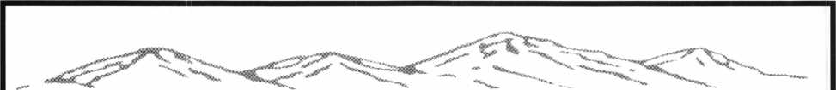

COLORADO SECURITY PROFESSIONALS  
EDUCATION CONFERENCE

APRIL 28-30, 2005  
RADISSON STAPLETON PLAZA HOTEL  
3333 QUEBEC STREET  
DENVER COLORADO 80207

(Hotel Reservation # 1 -800-333-3333 or 1 -303-321 -3500)

FULL DAY CLASS OFFERINGS  
STARTING THURSDAY

* Fundamentals of Locksmithing (3 days)
* Automotive Key Generation
* Safe Deposit Lock Service  
  + Essential Sales Training (2 days)
* Transponders, The Complete Story
* Comprehensive Safe Service,

Opening and Defeat Methods

* Your Bottom Line
* Professional Safe Penetration  
  + Understanding Alarm Systems

Classes with the (*) are ALOA ACE classes and the  
(+) are NBFAA classes.

EVENING EVENTS

THURSDAY Free dinner buffet and Trade Show.

FRIDAY Two free classes:

Selling Safes class sponsored by AMSEC  
False Dispatch Reduction Training sponsored by  
the Colorado Burglar & Fire Alarm Association.

SATURDAY Free Wiring Installation Class. Also several  
special ev ening clinics. Watch for updates.

ALOA PRP/STPRP sitting

For additional information or to register contact  
Gordon Racine CML or Barry Meyer CRL  
Gordon Racine CML 1 -719-384-4707 or  
e-mail [racine@rural-com.com](mailto:racine@rural-com.com)

Barry Meyer CPL 1 -303-688-4104 or  
e-mail acomal @Qwest.net

Or go to the website: [www.radisson.com/SecurityEducationWeekend](http://www.radisson.com/SecurityEducationWeekend)

**Brought to  
you by the  
following:**

**Central & Southern Colorado Locksmith Association**

**Rocky**

**Mountain**

**Locksmith**

**Association**

**Colorado  
Burglar & Fire  
Alarm  
Association**

**ALOA Front  
Range Chapter**

LOCK THE VOTE!

It will be time to vote soon! The membership meeting for the purpose of electing directors and officers and to decide whether or not to

make changes to the bylaws will be on June the 10^ at the ALOA Headquarters in Dallas. All members are encouraged to vote

in person or through the use of the proxy form that will be in the next issue of Keynotes.

The vote will be particularly important this year because several bylaws changes have been proposed by the Board. The first of these

changes is to require members to become PRP qualified. This does not necessarily mean taking a test. Registered Locksmith (RL) is a PRP  
designation that requires only that a member has taken a prescribed number of classes. Members will be required to renew their desig-

nation every three years through testing or classes. This change is proposed in an effort to upgrade the image of the locksmith. It adds  
credibility when ALOA represents its members to the congress, other parts of the security interest or the public. ALOA has long advocat-

ed testing as a part of the Model Law for Locksmith Licensing. Several new states adopted  
licensing laws last year. In order to be consistent with the laws, ALOA needs to maintain a  
higher standard for membership. Persons applying for membership in the future, who are  
not PRP qualified will enter the association as "Probationary" members and will not be  
allowed to renew after three years without achieving a PRP designation. (Although not a  
part of the bylaws changes, applicants are also now required to submit to a background  
check as a part of the application process.) The PRP requirement will have a "grandfather"  
provision. Long-time and/or older members will not be required to be PRP qualified or will  
have a longer time to comply.

The Board also proposes to add a "Company Membership". This will allow a locksmith  
company, institution or other entity employing multiple locksmiths to buy a "group" mem-  
bership. The membership will belong to the company, not the individual. This should

encourage companies to pay for employees to be members. The end result will be a larger membership. This will give ALOA additional

"clout" when dealing with governments and others sectors of the security industry.

The Board will also recommend that the bylaws be changed to eliminate one of the International Regions. Currently, there are two, the

"European" and "Asian" Regions. The Board proposes that these be combined to form the "International" Region. The Board went on to  
recommend that each region be represented by one or two directors as determined by the Board according to need. There are currently  
14 directors. The likely result of these changes is that, in time, the Board will have only 1 2 directors as was the case a few years ago.

In addition to voting on the bylaws changes, all members will have the opportunity to vote for the new ALOA president. Most regions  
will also have choices to make concerning directors. ALOA is owned by the members. Take your ownership seriously and vote in the  
next election. Look for proxy forms (ballots) in the next Keynotes and at aloa.org.



**THE HINGE DOCTOR**

**by GKL Products**

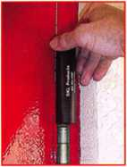

**HA1 For  
Standard**

**Commercial**

**4-1/2" x 4-1/2"**

**Butt Hinges**

**HA2**

*"The HULK*

**For Residential**

COMING IN  
SEPTEMBER

**HA3**

**For Ball- Bearing**

**Commercial Hinges**

**The Hinge Doctor is a great way to repair those sagging metal  
doors. Slip the tool over the hinge and open the door an inch**

**or two past the point where the tool binds against the  
hinge, remove the tool and check the door,**

**which should now be working properly.**

**If you're a locksmith these tools  
will turn a profit the 1st time you  
use them!  
Uses - schools, hospitals,**

**commercial buildings, storefronts**

**with butt hinges, office doors, new**

**construction, door alignment, sagging**

**doors, jail cells, anywhere there are  
commercial grade hinges.**

**HA4**

**For Prison**

**& Institutional**

**Hinges &**

**Spring Hinges**

Over

**10,000**

Satisfied

Customers

US Patent

#6450003

**[www.hingedoctor.com](http://www.hingedoctor.com)**

**800-924-5397**

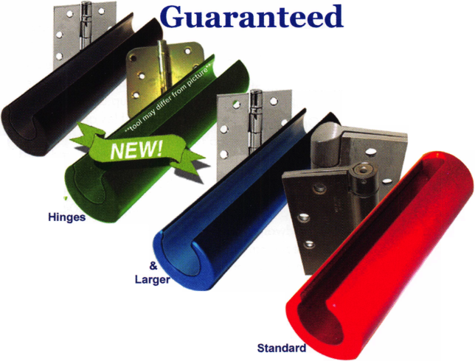

Classifieds



EMPLOYMENT

LOCKSMITH WANTED

Arapahoe County Security Center in Aurora, Colorado. Experience required in Access Control, Keyless Entry, Safes, Commercial Hardware

as well as some automotive experience. Benefits include: Vacation Pay, Health Insurance, 401 K, Company Vehicle and possible 4 day work week. Please contact Sheila or Paul at 303-745-5500 or fax to 303-745-5567.

EXPERIENCED LOCKSMITH NEEDED

Harbison Lock & Key, 25 year old commer­cial/residential locksmith company is seek­ing a qualified technician to join their team in servicing the Homewood, AL and sur­rounding municipalities. This is a full time position, pay commiserate with experience, paid health/dental insurance, paid holi­days and paid vacation. FOR MORE INFORMATION CALL 205-870-9920 or visit our website, [www.harbisonlock.com](http://www.harbisonlock.com).

LOCKSMITH FOR HIRE

New York Licensed Locksmith with 25+ years exp. in running and maintaining an In-house Locksmith shop is looking for a new position. Experienced in Masterkeying, Removable core systems, Simplex combination locks, Lock-Alarm hardware, desk and cabinet hardware, door-closers, etc. This ALOA and Nyail (NY Assoc. In-house Locksmiths) member is available for work immediately. Resume is available upon request. Call or Email Richard Sommers at (914) 734-2303

[Bestkey@Optonline.net](mailto:Bestkey@Optonline.net).

SEEKING POSITION:

Locksmith/Key System Specialist/Physical Security Specialist/Sales Engineer/Project Manager. I am seeking a position that will utilize my many years of commercial lock- smithing. I am experienced in commercial installations, design and lay out of large master key systems, access control, CCTV. Have been an instructor to commercial accounts on basic locksmithing, master key systems, access control systems, and CCTV systems. I started my locksmithing career in a 4 year apprenticeship program and worked my way up to sales engineer/proj- ect manager in mechanical locking hard­ware, electronic locking hardware, access control and CCTV. I hold a current North Carolina locksmith license. I am a past Chapter Chairman of the Greater Charlotte Chapter 65 of the American Society for Industrial Security and a 3 time United States Patent holder for the security indus­try. Upon request a full resume will be pro­vided. Please give company name, loca­tion, contact name, and phone number or E-mail address, Make all Inquires to 704/537-9161 or E-mail [RCHARREB5@AOL.COM](mailto:RCHARREB5@AOL.COM)

MANAGER OF TRAINING

($70-80 Base plus bonus, great benefits!) Reports to the Director of HR, dotted line to the VP of Sales and Operations. High ener­gy performer who can create, develop, implement, and manage national technical training programs. This person will set up Training from "ground zero" with two main initial priorities: 1) to set up a national pro­gram for over 5000 Hardware stores across the US needing technical training with advance Key Cutting and leading edge Locksmithing skills. These are private­ly held stores that have the company's key cutting machines in their stores and need to be trained. 2) To set up a comprehensive training program for the new start up Kiosk Division now with 52 locations in a major

DIY retailer in New Jersey. This will include an incremental training series to grow peo­ple from an "apprentice" type program to advanced "Transponder technology" (com­puter chipped keys) in a relatively short period of time. This division is expecting national growth and expanded market share. The overall vision for training will be the development and growth of highly trained, customer focused employees. Heavy project and vendor management.

For immediate consideration, please con­tact: Carla McBride, CPC, Valiant Enterprises, 216-261-7210 or email

[greatrecruiters@earthlink.net](mailto:greatrecruiters@earthlink.net).

WANTED TO BUY/SELL

FOR SALE

The International Safe Museum of Ocala, Florida has museum videos for sale.

$25.00 each, including shipping/han­dling. Contact Irving Isicoff at 1-800-854- 9681 to get your copy. Supply is limited.

FOR SALE

Over 340 brands and model numbers safe deposit locks, over 16,000 square feet of new and refurbished sales, night deposito­ries, safe deposit boxes, teller lockers, drive up drawers, undercounter steel fire proof files and vault doors, timelocks, teller locks, combination locks and thousands of miscellaneous and hard-to-find items. Fast service, credit cards accepted.

Underwood Safe & Vault, Inc. 1-800-642- 8763, fax 580-584-7720, website: [www.underwoodsafe.com](http://www.underwoodsafe.com).

Email: [safe@underwoodsafe.com](mailto:safe@underwoodsafe.com) or [under- woodsafe@yahoo.com](mailto:under-woodsafe@yahoo.com).

BUSINESS FOR SALE

35 years in same location. Need qualified locksmith, maybe two. Only locksmith in three counties. We are busy, busy. Owner must retire due to age and health.

Everything is paid for, building equipment and van. Beautiful West Texas weather and people. Priced to sell. Call or phone Dean Tedford, 432-336-3278

BUSINESS FOR SALE

Growing East Tennessee locksmith business, established 1987. Supports three locksmiths with two fully equipped vans. Serves shop and residential customers as well as commercial accounts. Lot and building, located on corner fronting main highway through town, included in sale of business for $220,000. Call 423-586-3101 Monday- Friday, 8-5 EST.

FOR SALE IN SUNNY CARIBBEAN

and busy Island of St. Thomas, U.S. Virgin Islands. Est in 1981.2 Trucks, 50,000 + in inventory and many other assets. Rental location is busy shopping mall with lease to 2007 with additional 3 yrs. possible. Currant Gross is 300,000 + per year. No financing by owners who are looking to retire. Cash only of $250K. Serious inquiries only to lipl [33@islands.vi](mailto:33@islands.vi).

EQUIPMENT FOR SALE

Mounted Locknetic Sample For Sale: CM5190- MGKx626 mounted on a oak mount asking $100 Primus Demo Kit[/b] New asking $75.00 [kishjohn@comcast.net](mailto:kishjohn@comcast.net) Telephone is 412-400-5900

WHOLESALE SAFE DEPOSIT LOCKS

Diebold, Herring Hall Marvin, llco, LeFebure, Mosler, Precision, S&G, Security Corp, Yale. Now available Safe Deposit Boxes Sections, Doors, Hinges and Bond Tins. Vault Doors, Safes, Night Depositories, Vault Lockers and One Inch Plate Steel are also stocked items. Call WBI (954)484-2404 or [Sales@WBI.US](mailto:Sales@WBI.US).

FOR SALE

DEXTER Deadbolts for sale. 4009 4109 4209 Over 250 for sale. Finish: 3 & 7A. Would rather not ship, however can be neg. Call 734-668-6863 M-F 08:30 am - 05:00 pm EST. Vogel's Lock & Safe Ask for Robert.

BUSINESS FOR SALE

Lock and safe company serving south eastern Pennsylvania and sourthern New Jersey. Fully stocked van with G.P.S. navigation system, custom lighting

package, computer, ITL and HPC code machines, tools, inventory. Great area and customer base. Will train if necessary and help through owner transition. Call 800- 648-9962.

FOR SALE

Kaba 1550-S PowerLever door lock, black body/chrome lever w/cylinder. This is an extra that we don't need; absolutely brand new, never removed from original packaging. List is $660. Sell for $300, which includes shipping anywhere in the contiguous U.S. Please email [selectlocks@aol.com](mailto:selectlocks@aol.com). Or write to George Kenney, 696 San Ramon Valley Blvd., Suite 221, Danville, CA 94526.

PRICE REDUCED!!

Opportunity of a Lifetime!! 28 year established, well equipped mobile lock shop. Inventory, tools, truck and monthly alarm income. Approximately $150,000 whole­sale cost. Will sacrifice for quick sale for only $91,000!!! (Check E-Bay = DENVER LOCKSMITH) or Call: 303-795-7600 or E-mail: [stanl926@quest.net](mailto:stanl926@quest.net).

FOR SALE

Abloy Disklock key cutting machine model 6200 with original instructions and 25 disc key blanks. No more than 100 keys have been cut on this machine, which is in like-new condition. Original price was $1775.00. Selling price $750.00. Includes shipping anywhere in the U.S. Contact Richard Grudens, Edison Locksmith, [rgrudensl@aol.com](mailto:rgrudensl@aol.com), or fax 631-862-0319.

RELOCATE ■ HELP WANTED

Qualified locksmiths needed in a fast-paced commercial and residential locksmith company. Located in Charlotte, North Carolina, home of the world renowned NFL Carolina Panthers, NBA Charlotte Bobcats, and Nascar's Lowe Motor Speedway. Candidates should have minimum of 3 years7 experience, good driving record, be self motivated, have good customer service skills, and be able to work unsupervised. Applicants required to pass background check and must be regis­tered by the NC Alarm Systems Licensing Board.

Benefits include: health, dental, life, 401k, paid vaca­tion, sick days, and company vehicle. Contact informa­tion: Eastway Lock and Key, 3807 Monroe Road, Charlotte, NC 28205 Attn: Joe Merola, VP/General Manager 800-301-5397, or fax: 888-301-5397.

Classified Advertising Policy

Classified advertising space is provided free of charge to ALOA members and for a fee of $2.00 per word, $40.00 minimum for non members. Classified ads may be used to advertise used merchandise and overstocked items for sale, "wanted to buy" items, business opportunities, employment opportunities/positions wanted and the like. Members or non members wishing to advertise services or new mer­chandise for sale may purchase a "Commercial Classified Ad" for a fee of $4.00 per word with a minimum of $100.00. Each ad will run for two issues. For blind boxes there is a $10.00 charge for members and non members. All ads must be submitted in writing to the Advertising Sales Department via fax at 817-645-7599 or through an email to [adsales@aloa.org](mailto:adsales@aloa.org) by the fifteenth of the month two months prior to issue date. ALOA reserves the right to refuse any classified advertisement that it deems inappropriate according to the stated purpose of the classified advertising section.



Distributor

**1 st In Hardware, Inc.**

Phone: 866-397-9900 Fax: 866-646-0045 www. 1 stinhardware.com

**ADI Inc.**

Phone: 631-692-1000 Fax: 631-692-3011

**Accredited Lock Supply Co.**

Phone: 800-652-2835 Fax: 201-865-0030 [www.acclock.com](http://www.acclock.com)

**Ace Lock & Security Supply**

Phone: 800-223-5625 Fax: 908-688-2442 [www.acelock.com](http://www.acelock.com)

**Andrews Wholesale Lock Supply**

Phone: 717-272-7422 Fax: 717-274-8659 [www.andrewslock.com](http://www.andrewslock.com)

**Boyle & Chase Inc.**

Phone: 800-325-2530 Fax: 800-205-3500 [www.boyleandchase.com](http://www.boyleandchase.com)

**Chinrose International**

Phone: 503-357-7553 Fax: 503-357-5522 [www.chinrose.com](http://www.chinrose.com)

**Clark Security Products**

Phone: 888-784-1311 Fax: 619-718-7333 [www.clarksecurity.com](http://www.clarksecurity.com)

**Cook's Building Specialties**

Phone: 505-883-5701 Fax: 505-883-5704

**Dire's Lock & Key Company**

Phone: 303-294-0176 Fax: 303-294-0198

**Direct Security Supply, Inc.**

Phone: 800-252-5757 Fax: 800-452-8600

**Discount Key Machines.Com/Busch**

Phone: 800-332-8724 Fax: 407-363-4666

**Doyle Security Products**

Phone: 800-333-6953 Fax: 612-521-0166 [www.doylesecurity.com](http://www.doylesecurity.com)

**Dugmore and Duncan, Inc.**

Phone: 888-384-6673 Fax: 888-329-3846

associate



**members**

**E. L. Reinhardt Co., Inc.**

Phone: 800-328-131 1 Fax: 651-481-0166 [www.elreinhardt.com](http://www.elreinhardt.com)

**Ewert Wholesale Hardware**

Phone: 800-451-0200 Fax: 708-597-0881

**Fairway Supply, Inc.**

Phone: 214-350-0021 Fax: 214-352-4299 [www.fairwaysupply.com](http://www.fairwaysupply.com)

**Foley-Belsaw Company**

Phone: 800-821-3452 Fax: 816-483-5010 [www.foley-belsaw.com](http://www.foley-belsaw.com)

**Fried Brothers Inc.**

Phone: 800-523-2924 Fax: 215-592-1255 [www.fbisecurity.com](http://www.fbisecurity.com)

**Hans Johnsen Company**

Phone: 214-879-1550 Fax: 214-879-1530

**Hardware Agencies, Ltd.**

Phone: 416-462-1921 [www.hardwareagencies.com](http://www.hardwareagencies.com)

**IDN Incorporated**

Phone: 817-421-5470 Fax: 817-421-5468 [www.idn-inc.com](http://www.idn-inc.com)

**Instant Hardware Delivery, Inc**

Phone: 800-355-1 107 Fax: 800-663-8518

**Intermountain Lock & Supply**

Phone: 800-453-5386 Fax: 801-485-7205 [www.intermountainlock.com](http://www.intermountainlock.com)

**International Electronics, Inc**

Phone: 800-343-9502 Fax: 617-821-4443

**Jo Van Distributors**

Phone: 416-752-7249 Fax: 416-752-7282 [www.jovanlock.com](http://www.jovanlock.com)

**Lockmasters, Inc.**

Phone: 859-885-6041 Fax: 859-885-7093 [www.lockmasters.com](http://www.lockmasters.com)

**Locks Company**

Phone: 800-288-0801 Fax: 305-949-3619

**Locksmith Ledger International**

Phone: 770-886-0800 Fax: 770-889-7703 [www.lledger.com](http://www.lledger.com)

**M. Zion Company**

Phone: 212-349-8677 Fax: 212-964-0495 [www.mzion.com](http://www.mzion.com)

**McDonald Dash Locksmith Supply**

Phone: 800-238-7541 Fax: 901-366-0005 [www.mcdonalddash.com](http://www.mcdonalddash.com)

**Monaco Lock Co.**

Phone: 800-526-6094 Fax: 800-845-5625 [www.monacolock.com](http://www.monacolock.com)

**Omaha Wholesale Hardware**

Phone: 800-238-4566 Fax: 402-444-1664 [www.omahawh.com](http://www.omahawh.com)

**RA-Lock Company**

Phone: 972-775-6301 Fax: 972-775-6316 [www.ralock.com](http://www.ralock.com)

**Security Distributors Inc**

Phone: 800-333-6953 Fax: 612-524-0166

**Security House**

Phone: 905-669-5300 Fax: 905-660-6313 [www.securityhouselock.com](http://www.securityhouselock.com)

**Security Lock Distributors**

Phone: 800-847-5625

Fax: 800-878-6400

[www.securitylockdistributors.com](http://www.securitylockdistributors.com)

**Shin-An Enterprise Inc.**

Phone: 718-225-5380 Fax: 718-819-0723

**Southern Lock and Supply Co.**

Phone: 727-541-5536 Fax: 727-544-8278 [www.southernlock.com](http://www.southernlock.com)

**Stone & Berg Wholesale**

Phone: 800-225-7405 Fax: 800-535-5625

**The Locksmith Store Inc.**

Phone: 847-364-51 1 1 Fax: 847-364-5125 [www.locksmithstore.com](http://www.locksmithstore.com)

**Timemaster Inc.**

Phone: 859-259-1878 Fax: 859-255-0298 [www.time-master.com](http://www.time-master.com)

**Top Notch Distributors, Inc.**

Phone: 800-233-4210 Fax: 800-854-4146 [www.topnotch.bz](http://www.topnotch.bz)

**Turn 10 Wholesale**

Phone: 800-848-9790 Fax: 800-391-4553

**U.S. Lock Corp.**

Phone: 800-925-5000 Fax: 800-338-5625 [www.uslock.com](http://www.uslock.com)

**Wilson Safe Company**

Phone: 215-492-7100 Fax: 215-492-7104 [www.wilsonsafe.com](http://www.wilsonsafe.com)

Manufacturer

**A & B Safe Corporation**

Phone: 800-253-1267 Fax: 856-863-1208 [www.a-bsafecorp.com](http://www.a-bsafecorp.com)

**ABUS Lock Company**

Phone: 800-352-2287 Fax: 602-516-9934 [www.abus.com](http://www.abus.com)

**Access Security Products Ltd.**

Phone: 905-337-7874 Fax: 905-337-7873 [www.access-safe.com](http://www.access-safe.com)

**Adams Rite Mfg Company**

Phone: 800-872-3267 Fax: 800-232-7329 [www.adamsrite.com](http://www.adamsrite.com)

**Adesco Safe Mfg. Company**

Phone: 800-694-9340 Fax: 562-408-6427 [www.adesco.com](http://www.adesco.com)

**Adrian Steel Company**

Phone: 800-677-2726 Fax: 517-265-5834 [www.adriansteel.com](http://www.adriansteel.com)

**All Five Tool Company, Inc.**

Phone: 860-583-1691 Fax: 860-583-4516 [www.all5tool.com](http://www.all5tool.com)

**American Lock Company**

Phone: 708-534-2000 Fax: 708-534-0531 [www.armericanlock.com](http://www.armericanlock.com)

**American Security Products**

Phone: 909-685-9680X1083 Fax: 909-685-9685 [www.amsecusa.com](http://www.amsecusa.com)

**Best Metaline Inc.**

Phone: 714-441-0098 Fax: 714-441-0977

**38**

Keynotes • April 2005

associate

members

**Bianchi USA, Inc.**

Phone: 800-891-2118 Fax: 216-803-0202

**Buddy Products**

Phone: 800-886-8688 Fax: 312-733-8356 [www.buddyproducts.com](http://www.buddyproducts.com)

**CCL Security Products**

Phone: 800-733-8588 Fax: 847-537-1 800

**COMPX Security Products**

Phone: 864-297-6655 Fax: 864-297-9987 [www.compxnet.com](http://www.compxnet.com)

**D&D Technologies (USA), Inc.**

Phone: 714-677-1300X292 Fax: 714-677-1299 [www.ddtechusa.com](http://www.ddtechusa.com)

**DETEX Corp.**

Phone: 800-729-3839 Fax: 830-620-6711 [www.detex.com](http://www.detex.com)

**DORMA Architectural Hardware**

Phone: 717-336-3881 Fax: 717-336-2106 [www.dorma-usa](http://www.dorma-usa) .com

**Datakey Electronics**

Phone: 952-746-4066 Fax: 866-289-4212 [www.datakeyelectronics.com](http://www.datakeyelectronics.com)

**Don-Jo Manufacturing, Inc.**

Phone: 978-422-3213 Fax: 978-422-3467 [www.don-jo.com](http://www.don-jo.com)

**Door Controls International**

Phone: 800-742-3634 Fax: 800-742-0410 [www.doorcontrols.com](http://www.doorcontrols.com)

**ESP Lock Products Inc.**

Phone: 800-434-8960 Fax: 978-562-9859

**FireKing Security Products**

Phone: 800-457-2424 Fax: 800-896-6606 [www.fkisecuritygroup.com](http://www.fkisecuritygroup.com)

**Framon Manufacturing Company Inc.**

Phone: 989-354-5623 Fax: 989-354-4238 [www.framon.com](http://www.framon.com)

**HPC, Inc.**

Phone: 847-671-6280 Fax: 847-671-6343 [www.hpcworld.com](http://www.hpcworld.com)

**HY-KO Products Co.**

Phone: 330-467-7446 Fax: 330-467-7442

**Hammerhead Industries, Inc.**

Phone: 805-658-9922 Fax: 805-658-8833 [www.gearkeeper.com](http://www.gearkeeper.com)

**Ingersoll Rand SSA**

Phone: 317-613-8025 Fax: 317-613-8068 [www.schlagelock.com](http://www.schlagelock.com)

**Jet Hardware Mfg., Co.**

Phone: 718-257-9600 Fax: 71 8-257-0973 [www.jetkeys.com](http://www.jetkeys.com)

**KABA ILCO Corp.**

Phone: 252-446-3321 Fax: 252-446-4702 [www.kaba-ilco.com](http://www.kaba-ilco.com)

**KEY-BAK/West Coast Chain Mfg.**

Phone: 909-923-7800 Fax: 909-923-0024 [www.keybak.com](http://www.keybak.com)

**Keri Systems Inc.**

Phone: 408-451-2520 Fax: 408-441-0309 [www.kerisys.com](http://www.kerisys.com)

**Knaack Manufacturing Co.**

Phone: 800-456-7865 Fax: 815-459-9097 [www.weatherguard.com](http://www.weatherguard.com)

**LAB Security**

Phone: 800-243-8242 Fax: 860-583-7838 [www.labpins.com](http://www.labpins.com)

**La Gard Inc.**

Phone: 310-325-5670 Fax: 310-325-5615 [www.lagard.com](http://www.lagard.com)

**Lock America, Inc. dba L.A.I. Group**

Phone: 714-373-2993 Fax: 714-373-2998 [www.laigroup.com](http://www.laigroup.com)

**Lucky Line Products, Inc.**

Phone: 858-549-6699 Fax: 858-549-3241 [www.luckyline.com](http://www.luckyline.com)

**M.A.G. Security**

Phone: 714-891-5100 Fax: 714-892-6845 [www.magsecurity.com](http://www.magsecurity.com)

**MUL-T-LOCK USA, Inc.**

Phone: 800-562-3511 Fax: 973-778-4007 [www.mul-t-lock.com](http://www.mul-t-lock.com)

**Medeco Security Locks**

Phone: 540-380-5000 Fax: 540-380-5010 [www.medeco.com](http://www.medeco.com)

**ROFU International Corp.**

Phone: 253-922-1828 Fax: 253-922-1728 [www.rofu.com](http://www.rofu.com)

**Rutherford Controls Int'l Co.**

Phone: 757-427-1230 Fax: 757-427-9549 [www.rutherfordcontrols.com](http://www.rutherfordcontrols.com)

**STRATTEC Security Corp.**

Phone: 414-247-3415 Fax: 414-247-3692 [www.strattec.com](http://www.strattec.com)

**Sargent & Greenieaf, Inc.**

Phone: 800-826-7652X201 Fax: 859-885-3063 [www.sargentandgreenleaf.com](http://www.sargentandgreenleaf.com)

**Sargent Manufacturing Co.**

Phone: 800-727-5477 Fax: 888-863-5054 [www.sargentlock.com](http://www.sargentlock.com)

**Schwab Corp.**

Phone: 765-447-9470 Fax: 765-447-8278 [www.schwabcorp.com](http://www.schwabcorp.com)

**Securitron Magnalock Corp.**

Phone: 775-355-5625 Fax: 775-355-5636 [www.securitron.com](http://www.securitron.com)

**Security Door Controls**

Phone: 805-494-0622 Fax: 805-494-8861 [www.sdcsecurity.com](http://www.sdcsecurity.com)

**Security Solutions**

Phone: 405-376-1600 Fax: 405-376-6870

**Townsteel, Inc.**

Phone: 626-858-5080 Fax: 626-858-3393 [www.townsteel.com](http://www.townsteel.com)

**Trine Access Technology**

Phone: 718-829-2332 Fax: 718-829-6405 [www.trineonline.com](http://www.trineonline.com)

**UCA Inc**

Phone: 972-312-0599X12 Fax: 972-692-7056 [www.ibuttonlock.com](http://www.ibuttonlock.com)

**Victor E-lok, Inc.**

Phone: 949-916-1200 Fax: 949-916-1300 [www.victorelok.com](http://www.victorelok.com)

**Videx Inc.**

Phone: 541-758-0521 Fax: 541-752-5285 [www.videx.com](http://www.videx.com)

**YSG Door**

**Security Consultants, Inc.**

Phone: 800-438-1951 Fax: 800-338-0965

Service

Organization

**Allstate Insurance Company**

Phone: 800-859-0247 Fax: 847-326-7509 [www.allstate.com](http://www.allstate.com)

**Cross Country Automotive Services**

Phone: 800-541-2262 Fax: 781-393-0256 [www.argosi.com](http://www.argosi.com)

**Massglass & Door Service**

Phone: 888-742-8837 Fax: 805-497-2255 [www.massglass.com](http://www.massglass.com)

**Webster Safe & Lock Co., Inc.**

Phone: 901-332-2911 Fax: 901-332-2878 [www.webstersinc.com](http://www.webstersinc.com)

[www.securitysolutions-usa.com](http://www.securitysolutions-usa.com)

Keynotes • April 2005



CBS News Report Validates ALOA's Call for

"Motor Vehicle Right to Repair Act"

America's car owners are having increasing trouble getting their cars repaired, according to a recent CBS television "Consumer News Alert." John Roberts, anchor, says car deal­ers' service departments are gaining ground, and that could cost consumers time and money. The news segment aired last month on the "CBS Evening News with Dan Rather,"which reaches millions of viewers each night.

Says David Parde, president of the Coalition for Auto Repair Equality(CARE), "The trouble is caused by the car code monopoly, which may soon become illegal if a bill soon to be reintroduced in Congress becomes law."

The Motor Vehicle Owners' Right to Repair Act is a pro-con­sumer bill.It's about ownership and the right of consumers to choose where, how and by whom to have their vehicles repaired, even if they wish to work on them themselves. It ensures that all vehicle owners and independent auto service centers have access to the information necessary to diagnose and repair vehicles at an affordable cost.

The bill known as The Motor Vehicle Owners Right to Repair Act gained 1 1 8 co-sponsors in the U.S. House and 1 1 in the U.S. Senate before the close of the 108th Congress. It is expected to be re-introduced in this next Congress.

According to Parde, "The news report clearly validates what we have been saying all along, that the car companies are trying to create a "car code monopoly" to put the independ­ent repair shops out of business. We hope news reports like this will spur Congress to give the green light to the "Motor Vehicle Owners' Right to Repair Act."

Here are some interesting points from the news segment- note, Parde was not part of interview, we inserted his com­ments in brackets:

A Manhattan car dealership director openly admitted that the car companies depend on profits from service more than they do from sales. He says, "Parts and service side really is paying more and more of the bills of a business. And the industry's relying not so much on the profits from the sales and depending on service."

[Says Parde, "We have known this for years. The car makers are grabbing for a 'car code monopoly.'"] They want control of the service and repair information so that they can control the market.

A car company spokesman said, "All of our manufacturers have made the commitment and are supplying the exact same repair information to the independent technicians that we supply to the dealers now."

CBS correspondent Sharyn Alfonsi countered by saying, "But a recent survey paid for by independent mechanics found almost 60 percent ofthem say they couldn't access the infor­mation they needed, and more than 50 percent turned away customers."

Surprisingly, the Manhattan dealer concurred. He stated that the "the dealership definitely has a leg up" (on independent repair shops). He stated that 'the dealership gets their soft­

**40**

ware updated daily by a satellite link from the manufacturer, and that they couldn't do their jobs without it." Alfonsi summed up the segment by saying, "Meaning drivers may have to rely on the dealership to get that 'check engine light' fixed. And while that could drive some consumers crazy, it might also drive the independent mechanic out of business for good."

CARE represents companies in the automotive aftermarket, among them: The Associated Locksmiths of America, NAPA, Midas, CARQUEST, AutoZone, Advance Auto Parts, O'Reilly's, Jiffy Lube and CSK (parent company ofChecker, Schucks, Kragen). The automotive aftermarket is a $200 bil­lion a year industry employing up to five million people in over 495,000 locations.

Association Health Plan Update!

The House Education and Workforce Committee approved H.R. 525 (The Association Health Plan Bill) on a party-line vote of 25-22 this past week. The committee debated approximately 10 amendments, which mostly consisted of proposals offered by committee Democrats to require Association Health Plans (AHP's) to comply with certain man­dated benefit requirements. All of these amendments were defeated, mostly on straight party-line votes.

In addition, Rep. Charlie Norwood (R-GA) offered an amendment to strike the provision in H.R. 525 that would allow AHPs to adjust contribution rates based on health sta­tus to the extent such rating is allowed under the state law in which the employer is located. There was substantial debate on this amendment and it was defeated on a 24-24 tie vote (amendments that receive a tie vote are not agreed to). The Norwood amendment would strike section 805 (a)(2)(B)

(ii)(attached is the text of the Norwood amendment). The Norwood amendment received the support of all committee Democrats, Norwood and freshman Republican Rep. Tom Price of Georgia.

If you have questions or comments about the Norwood amendment and its implications (it is certainly possible this issue will again be raised when the Senate considers the bill), please let me know.

Many thanks to Chairman John Boehner (R-OH) and Employer/Employee Subcommittee Chair Sam Johnson (R-TX) for their usual strong leadership in sheparding H.R. 525 through the committee process once again. Also, many thanks to Reps. Nydia Velazquez (D-NY) and Al Wynn (D- MD), who garnered the signatures of 14 House Democrats (not on the E&W Committee) on a letter to Chairman Boehner in support of H.R. 525 (let me know if you would like a hard copy of this letter).

The next step of course will be consideration of H.R. 525 on the House floor, which will likely take place sometime this spring. I will let you know as soon as we have a better idea of exactly when floor consideration will take place.

Regards,



Keynotes • April 2005

**THE LAST GREAT ★ ★★**

**MADE IN THE USA**

**RELOCKER:**

Independent

spring-loaded

relocker

**HINGES:**

Heavy duty, adjustable solid steel block hinges

**BODY & DOOR:**

Thick outer and inner steel plates encase high density fire barrier material.

**BOLTWORK:**

3-way boltwork with 6 massive 1” diameter solid steel bolts

**LOCK:**

UL-listed high security Group II combination lock. Drill-resistant steel hardplate.

**ADDITIONAL**

**FEATURES**

Light gray finish Adjustable shelving Mounted on 4 rubber feet (removable). Pre­drilled boltdown hole.

**OPTIONS**

Electronic digital pushbutton locks. Additional shelving available.

**UL Class 350 1 Hour Fire & Impact Rated - 3 Sizes Available**

PATRIOT

**DEFIANT SAFE COMPANY Dallas, Texas**

1-800-225-2984

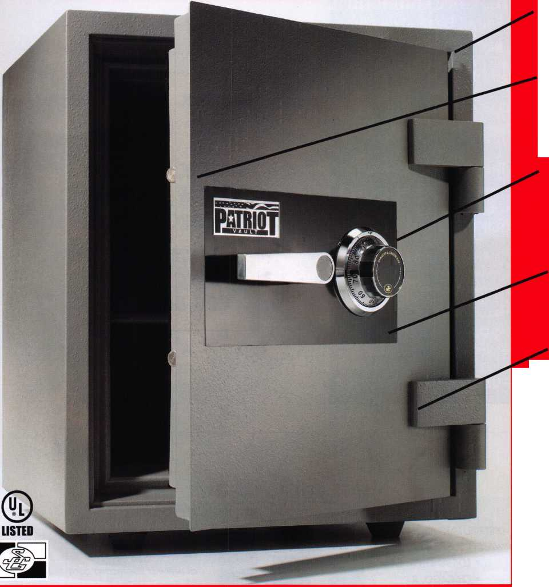

Buyer's_Marketplace

**oiAFI**

**IC CoreThumbturn For all Best® style cores**

**The only place you can get**

**KOTE\***

**Toll Free 1 (866) 839-6286 ^REE shipping on orders of 10 or more**

**(within the 48 United States)**

**^6.0.D. orders accepted for  
Institutional customers**

**FULLER 330*. LOC<, illC.**

IN-STOCK...MORE SAFES

***FREE Freight Program***

***(30 States)***

AMSEC FireKing

Qardall **hayman**

MEIUNK **yicron**

TURD 10

**WHOLESALE SERVICE**

800-848-9790



**SAFE CORPORATION**

MANUFACTURES OF QUAUTY DEPOSITORY SAFES AND CHESTS

DISTRIBUTING FROM WAREHOUSES IN *• LOS ANGLES, CA*

* CHICAGO, IL
* GLASSBORO, NJ

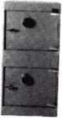

AB-4-30-3S AB-9-2 WS10-2

Chose from over 75 models in stock

A & B is now a stocking  
for Mutual Safes

featuring

distributor

We ship your order within

24 hours

See us

at [www.a-bsafecorp.com](http://www.a-bsafecorp.com) *800-253-1267*

Fax 856-863-1208

CALL FOR YOUR CATALOG TODAY

Keynotes • April 2005

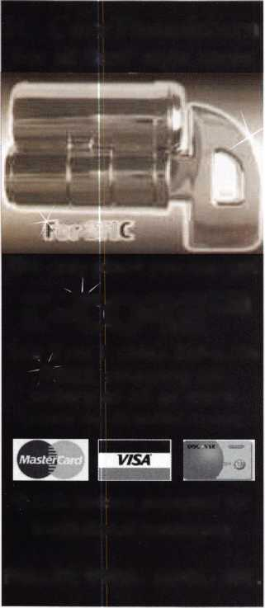

call me.

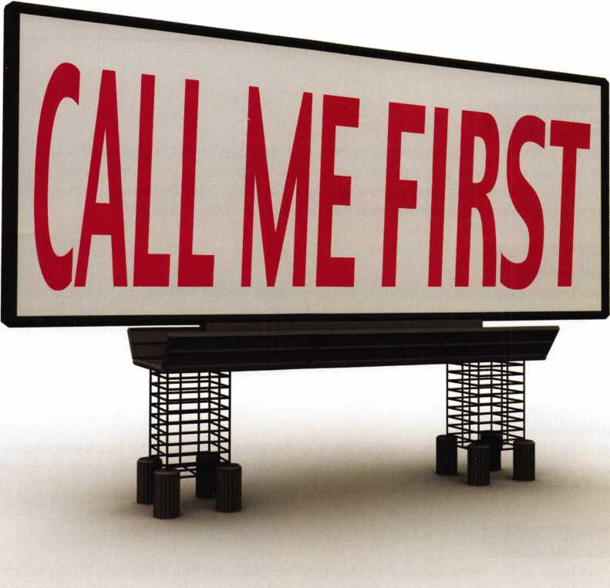

which one catches your attention?

Bigger is sometimes better. And when someone is in need of your services, you want to take every opportunity to make your name prominent in the minds of searching consumers.

Introducing a new advertising solution from ALOA. At our new public locksmith search site, findalocksmith.com, you can now purchase an ad for your business that will shine brightly on the results page whenever someone searches for a locksmith in your zip code. The initial cost is only $30.00, and each additional zip code you add is only $5 extra. Don't miss this great opportunity!

Call Kim Hammond at 817-645-6778 for details.

Spaces for each zip code are limited. Call to reserve yours now!

about the authors

**Greg Perry, CML, CPS**

Greg Perry, CML, CPS is a Certified ACE Instructor, a long-time member of ALOA and SAVTA and has taught access control and safe lock classes on a local and national basis. He is the author of the SafeData CD Rom database refer­ence program and has written numerous articles for Keynotes, Safe and Vault Technology and other publications. Greg has been the recipient of Keynotes’ Author of the Year Award twice (in 2002 and 2003).

**T.F. Stern, RL**

T. F. Stern is owner and sole operator of T. F. Stern & Co. in Houston, Texas. T. F. has been involved in the locksmith business since 1976 specializing as a mobile automotive locksmith, servicing car dealerships, dealership referrals and providing retail locksmith services with no set hours of operation. T.F. has trained several qualified locksmiths in the Houston area, not for them to be employees; rather for them to realize their own dream of becoming professional lock­smiths and owning their own businesses.

**Robert Schuetrumpf, CRL**

Robert Schuetrumpf, CRL, has over 24 years of experience in the locksmith trade and has been employed by the College of New Jersey in the office of Access Control Services since March, 2003. He is currently the president of the Greater Philadelphia Locksmiths Association. This is his first article for Keynotes.

**Eric Costley, CRL**

Eric Costley, CRL, has been active in the locksmith industry since 1980. He has a bachelor’s degree from Gardner-Webb University, and has worked in shops in Arizona, Noth Carolina and New York. He is currently employed by Bill’s Locksmithing in Elmira, New York. Eric’s hobbies include music and raising tarantulas.

**Claire Cohen**

Claire L. Cohen, the second woman to become a CML, has been in locksmithing since 1977, and has been writing arti­cles for Keynotes since 1987. She is also a contributing editor for Keynotes, and received the 2001 Keynotes Author of the Year Award. She is only the second woman to receive that honor.

Keynotes • April 2005

IN THE WAR ON CRIME, YOU DON'T NEED A PADLOC YOU NEED AN ARSENAL,

You’re constantly fighting crime on many fronts. That’s why we manufacture a complete line of commercial padlocks, each one tough enough to be called a Master Lock. It’s the name trusted the world over for quality padlock security. Whether you’re battling theft, unauthorized entry or the elements, we can arm you with a solid solution for any industrial application, even safety lockout. So make our commercial line your W/g

first line of defense. For more information, contact your local

distributor, or call 1-800-3 08-9244.

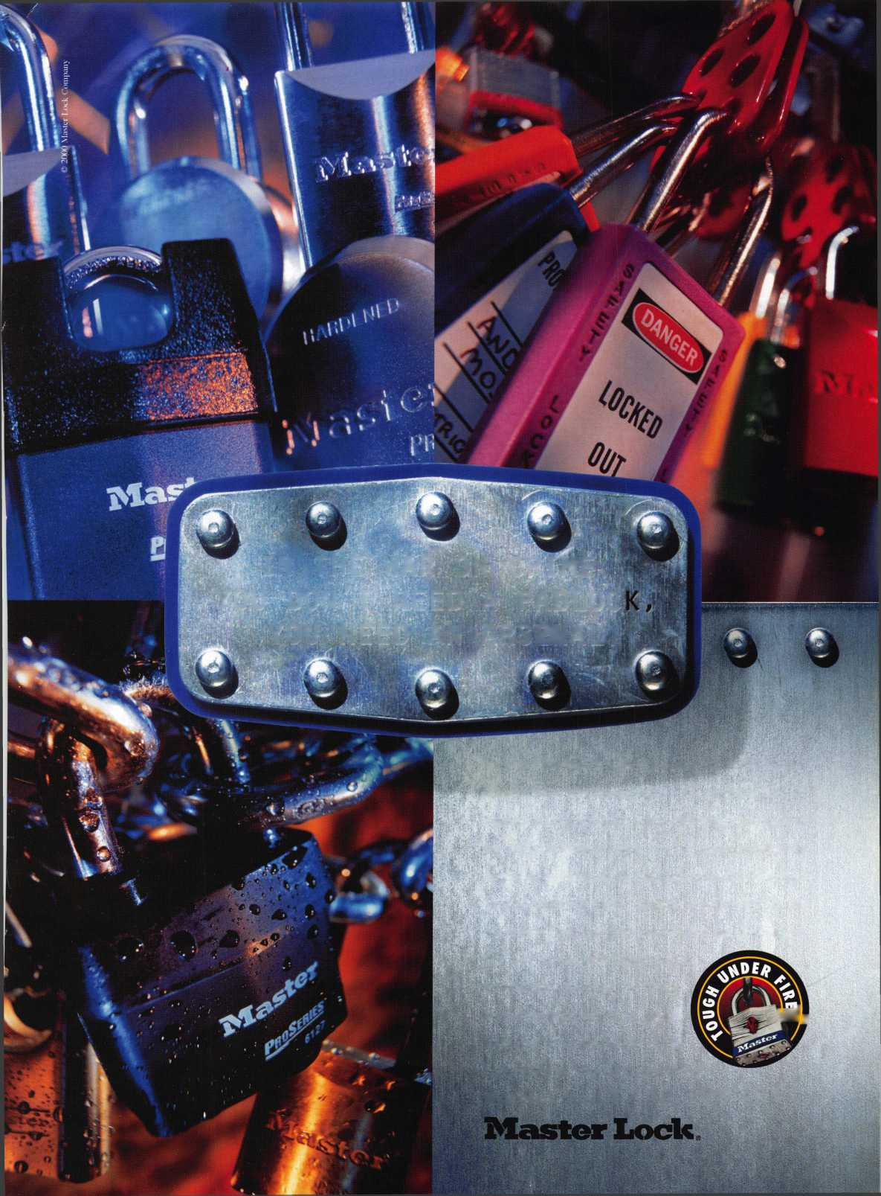

**SearchAlert**

Prevents Surreptitious Entry at Airports.

Know when your bag has been searched by a TSA agent or violated by an unknown person.

*ako amiobh:*

Black Fire Engine Red

Pewter Purple Grape

Bright Nickel Construction Orange  
Brass Plated Cobalt Blue  
Hot Pink



Recognized by the TSA

Security Window

I lock has been opened

lock not opened

**TRAVEL SENTRY**

CERTIFIED



Security Products

301 West Hintz Road • Wheeling, IL 60090 800.733.8588 • Fax: 847.537.1881 • [www.cclsecurity.com](http://www.cclsecurity.com)

